**Introduction SAP BI**

**Details**

Last Updated: Friday, 05 August 2016 07:08

Business intelligence (BI) is an application used for giving meaning to raw data that an organization has. The raw data is cleansed, stored and applied with business logics to be useful for enterprise users to make better business decisions. This data can be presented in the form of reports and can be displayed in the form of tables, charts etc. which is efficient and easier to analyse and make business decisions.

During all business activities, companies create data about customers, suppliers and internal activities. Based on these data’s, employees of various departments like HR, Finance, Accounting, Marketing etc. prepare their work plan.

Business Intelligence spans a varied set of toolset, of which the Data Ware House consolidates and loads the data from the different Source Systems, while reporting tools like Query Designer, Web Application Designer, and Analyzer are majorly used to create reports which display the data consolidated by the Datawarehouse for analysing purpose.

Business Intelligence is a SAP product which majorly focuses on providing its customers/organizations with a user friendly and very useful form of representing data that could be helpful for analyses purpose and making business decisions.

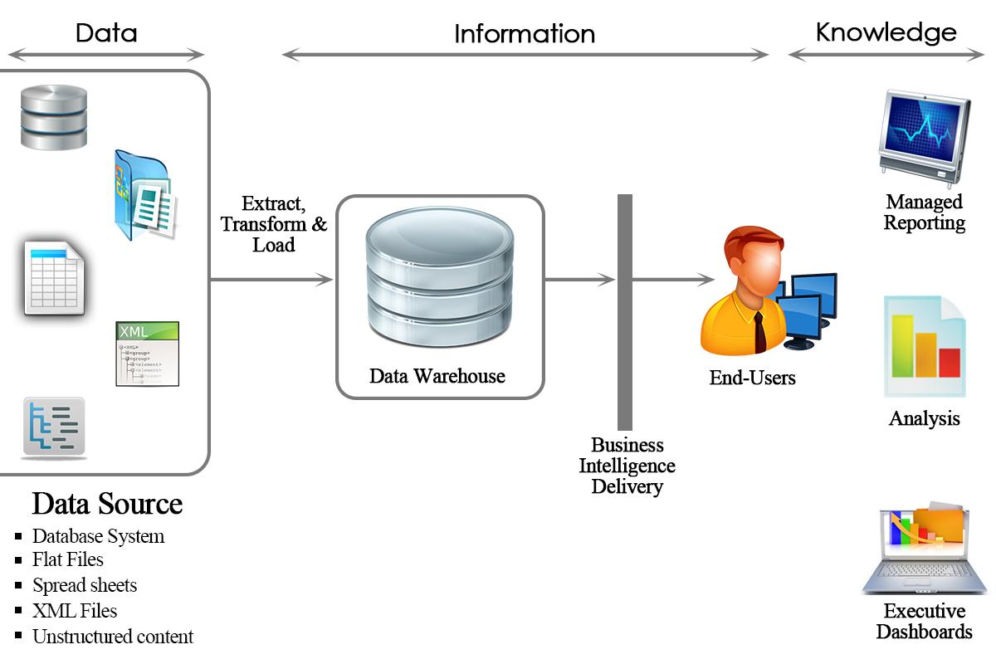

In summary, Business Intelligence tools transform raw data into reports which used for decision making and business forecasting.

**Why do we need Datawarehouse & BI ?**

Organizations have different kinds of data such as finance, Human resource, customer, supplier data etc., which can be stored on different kinds of storage units such as DBMS, excel sheets, SAP R/3 systems etc...Even the company's internal data is often distributed across many different systems and is not particularly well formatted.

[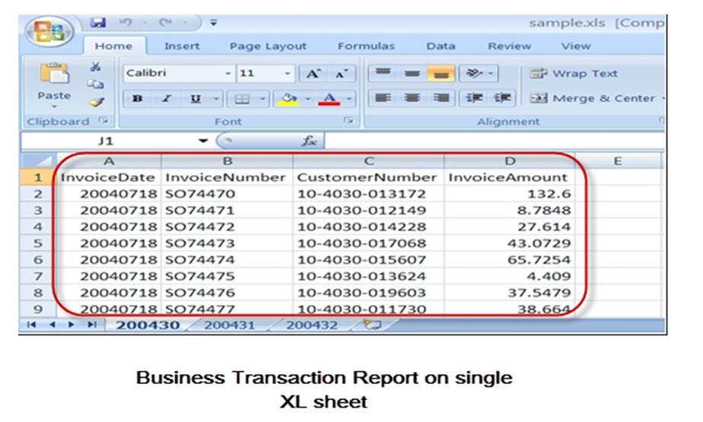](http://cdn.guru99.com/images/sap/SAP_BI/sap_bi_1_2.jpg)

A Data Warehouse can help to organize the data. It brings together heterogeneous Data Sources which are mostly and differing in their details. Using BI Tools one can derive meaningful reports

**What makes SAP BI more effective BI tool?**

* Single point of access to all information is possible through BI. The data from various sources can be accessed at the single place(i.e BI).
* Data collected from various sources are presented in the form of reports which is efficient for analysis of the data at a high level.
* SAP BI provides easy to use GUI and better formatting
* Some of the key functionality that makes SAP BI better than rest is its ability to analyze **multidimensional** data sources in both web and MS office environments, flexible dashboards, mobility and a flexible, scalable BI platform.
* SAP BI is known for its awesome **query performance**, while requiring little administration
* **Mobile BI** for end users on the go
* **Easy Integration** with other platforms

**SAP BI/ Data Warehouse Vs. OLTP systems:**

**OLTP(Online Transaction Processing):**

These systems have detailed day to day transaction data which keeps changing. For example, R/3 or any other database.

**OLAP(Online Analytical Processing):**

These systems have data for analysis purpose. The input for this system is from OLTP systems. The data from the OLTP systems is made use to prepare the data for analysis purpose.

Business Intelligence is an OLAP system.

|  |  |  |
| --- | --- | --- |
|  | **OLTP Systems** **(Operative Environment)** | **DWH/OLAP Systems(Informative Environment)** |
| Target | Efficiency through automation of business processes | Generating Knowledge (Competitive Advantage) |
| Priorities | High availability, higher data volume | Simple to use, flexible access to data |
| View of Data | Detailed | Frequently aggregated |
| Age of Data | Current | Historical |
| Database operations | Add, Modify, delete, update and read | Read |
| Typical data structures | Relational(flat tables, high normalization | Multidimensional Structure |
| Integration of data from various modules/applications | Minimal | Comprehensive |
| Dataset | 6-18 months | 27 years |
| Archiving | Yes | Yes |

**Overview of SAP BI Architecture**

**Details**

Last Updated: Sunday, 04 September 2016 16:00

Before we learn more about SAP BI Architecture, lets learn about

**Conceptual Layers of Data Warehousing with BI**

[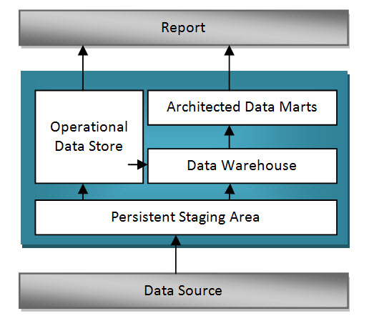](http://cdn.guru99.com/images/sap/SAP_BI/sap_bi_2_1.jpg)

**Persistent Staging Area**

The data extracted from the Source Systems first enters into the Persistent Staging Area. The data at this layer is the raw data which is in unchanged form. The data is consolidated and cleansed only in the next layers.

Staging area is a temporary table that holds the data and connects to work area or fact tables.  In the absence of staging area the data load will have to go from the OLTP system to the OLAP system directly which hamper the performance of OLTP system.

**Data Warehouse Layer (DWH Layer)**

Data from the Persistent Staging Area is loaded into the DataWareHouse Layer. It has Corporate information repository. Data in this layer is stored for a longer period.i.e,Entire History data (for example, last 5 years data) is stored here in this layer.No aggregation of reporting-relevant data;the granularity of the data stored in this layer is at line-item (detailed) level.

**Operational Data Store Layer**

Data is loaded to an Operational Data Store Layer very frequently on a continuous basis from the source systems. Hence the data in this layer contains all the changes to the data that was done throughout the day. Data from Operational data store later can be loaded to the Datawarehouse layer at particular timings (say end of the day) to update the date in Datawarehouse Layer. This Operational Data Store Layer can also be used in case of any emergencies when the data in the datawarehouse and datamart layers are lost. In such situations data can be loaded from the Operational Data Store layer to the Data Warehouse Layer and Data Mart Layer. ODS is not based on star schema model but they are in a flat files format.

**Architected Data Mart Layer**

Architected Data Mart Layer also known as Infocube. It is designed to store summarized and aggregated Data for long period of time.  Data from the Data Warehouse Layer is loaded into the Architected Data Mart Layer. It is used in Analysis and reporting. The data is at a high level relevant for creating reports displaying these data. Data manipulation with business logic is done at this layer. It consists of a central fact table(Key Figures) surrounded by several dimension tables, it is used to support BI queries

**Key Components of SAP  BI System:**

Business Intelligence is a core component of SAP NetWeaver. The figure below shows the key components of a BI system.

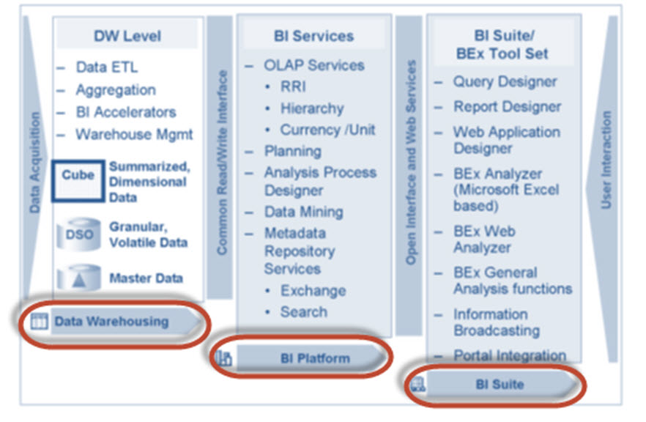

* ***Data warehousing*** – This is mainly to Extract, Transform and Load data from Source systems.
* ***BI platform*** – The BI platform layer contains BI services to support complex analysis tasks and functions. It contains the Analytic Engine, which processes the data requested through BEx analysis navigations. Its interface allows entry and manipulation of data as part of BI Integrated Planning. It also has special analysis tools such as the Analysis Process Designer (APD) and the Data Mining which provide analysts at your company with the tools to merge, mine, pre-process, store, and analyse data.
* ***BI Suite*** – These tools helps in creating reports for analysis purpose.It contains the Business Explorer (BEx) which provides flexible reporting and analysis tools.

            The following areas in the Business Explorer can be used for Data Analyses:

1. BEx Analyser (Microsoft Excel-based analysis tool with pivot-table-like features)
2. BEx Web Analyser (Web-based analysis tool with pivot-table-like features)
3. BEx Web Application Designer (customer-defined and SAP BI Content provided)
4. BEx Report Designer (highly formatted Web output)

**SAP BI Architecture:**

BI has three tier architecture:

**Database Server:**Where data is physically stored.( ODS, PSA, Infocube and metadata repository).

**Application Server:**The application server is based on the OLAP processor. It is used to retrieve data stored in the database server.

**Presentation Server:**Manages reporting and data access.

1. Data is extracted from the Source Systems.
2. Data is staged at the Persistent Storage Area(PSA). This holds Source like data.
3. Data is cleansed, loaded and stored in Data Store Object.
4. Data is viewed at multiple dimensions in the Infocube.
5. Data is available by the OLAP processor to the Business Explorer to display data as per Analysis requirements of the Business.
6. Data can be made available to SAP/Non-SAP, Data Marts by the Open Hub Service.( InfoSpoke).

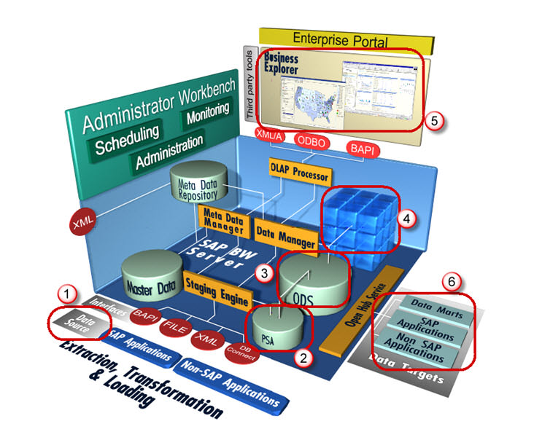

**All About Infoobject Infoarea & Infoobject Catalog**

**Details**

Last Updated: Sunday, 04 September 2016 16:00

**What is an InfoObjects?**

Info-Objects take information from the source, then adjust and arrange the information into either a standard or customized report.  Infoobjects are the smallest available information modules/fields in BI. **It is needed in info-providers like InfoCubes, DSOs, MultiProviders, Queries etc...  These Info-Providers are made up of Info-objects.**

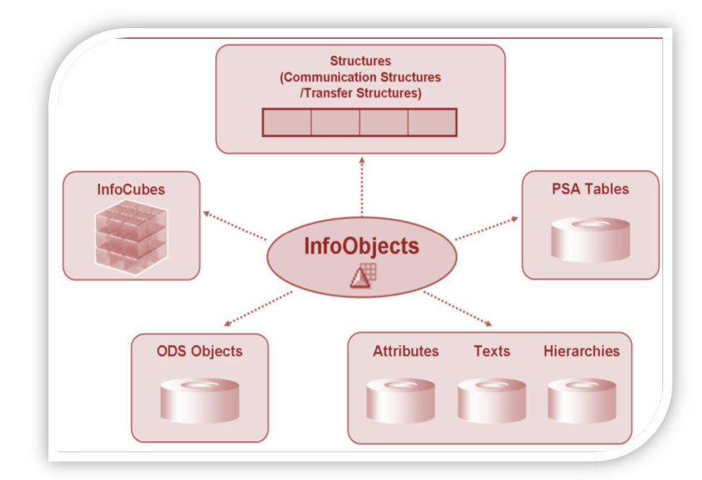

Info-object gives all information about the business. For instance company ‘XYZ’ is interested in finding out how much of “product x” shipped on “date x” to “factory x”.  By defining Info-object for specific function like “0MATERIAL”, “0DATE” and “0LOCATION” all the information can be retrieved.

InfoObjects can be classified into the following types:

* Characteristics (for example, customers)
* Key figures (for example, revenue)
* Units (for example, currency, amount unit)
* Time characteristics (for example, fiscal year)
* Technical characteristics (for example, request number)

**Characteristics:**

Characteristics are Business reference objects used to analyze key figures.

Examples of characteristics InfoObjects:

* Cost center (0COSTCENTER)
* Material(0MATERIAL)

**Keyfigures:**

Key figures provide the values to be evaluated. They are numeric information that is reported in the query.

Examples of key figure InfoObjects:

* Quantity (0QUANTITY)
* Amount (0AMOUNT)

**Units:**

Units are paired with Key figure values . They provide assign a unit of measurement to a Key Figure Value. For instance 10 Kg where 10 is the KeyFigure and Kg is the unit

Other Examples of Unit Characteristics:

* Currency unit (0CURRENCY) (Holds the currency type of the transaction e.g. $, EUR, USD...)
* Value unit (0UNIT)  (or) unit of measure (Hold the unit of measure e.g. Gallon, Inch, cm, PC)

**Time Characteristic:**

Time characteristics give time reference to data.

Examples of Time Characteristics:

* Calendar day (0CALDAY)
* Calendar year (0CALYEAR)
* Fiscal year (0FISCYEAR)

**Technical Characteristics:**

Technical characteristics are SAP standard objects having their own administrative purposes.

Examples of Technical Characteristics:

* Info Object 0REQUID – While loading data to various data targets,  SAP allocates unique numbers which are stored in this Info object
* Info Object 0CHNGID – When aggregate change run is done, a unique number is allocated and stored in this info object.

**Before creating an Info Object, Info Area and Info Object Catalog need to be created.**

**What is an InfoArea?**

* In Business Warehouse, Info-areas are the branches and nodes of a tree structure.
* It is used to organize info cubes and info objects.
* Each Info-object is assigned to an Info Area.
* Info Area can be thought of as a folder used to hold related files together.

**What is Infoobject Catalog?**

* Every info object need to be created within an Info Object Catalog.
* It helps in organization and is no way related to reporting functions.
* Example: There are tons of InfoObjects for SAP Financials which can be clubbed into a InfoObject Catalog.  This makes management and maintainence easy.
* An Info Object can be assigned to multiple Catalog

There are 2 types of Info Object Catalog.

1. Characteristic Info Object Catalog
2. Key figure Info Object Catalog

**Here is the RoadMAP to create an Infoobject**

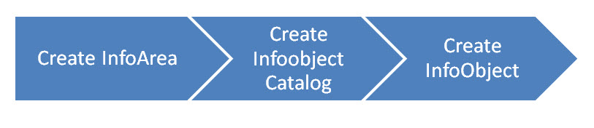

**How To Create an Infoarea?**

**Details**

Last Updated: Sunday, 04 September 2016 16:00

**Step 1)**

1. Go to transaction code RSA1 to go to the Data Warehouse Workbench.
2. Click the OK button.

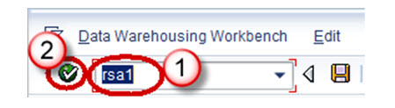

**Step 2)**

1. Navigate to Modeling ->InfoProvider
2. Right click in the Workbench and Create an InfoArea

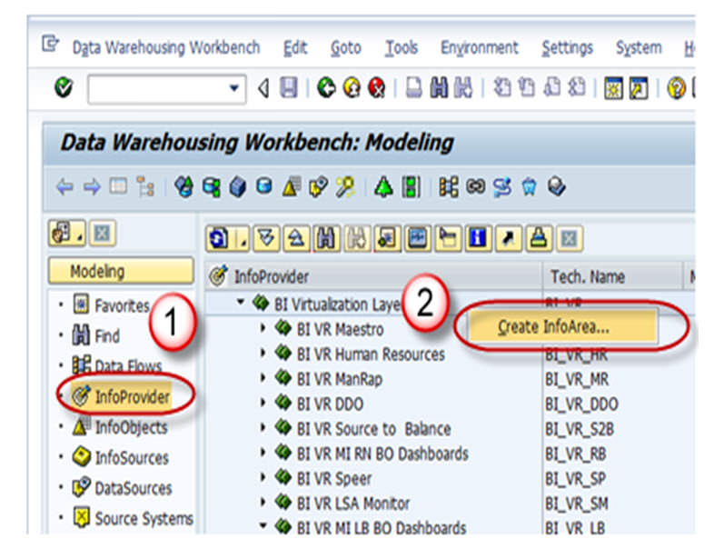

**Step 3)**

1. Enter the Technical Name
2. Enter the Description
3. Press the enter button

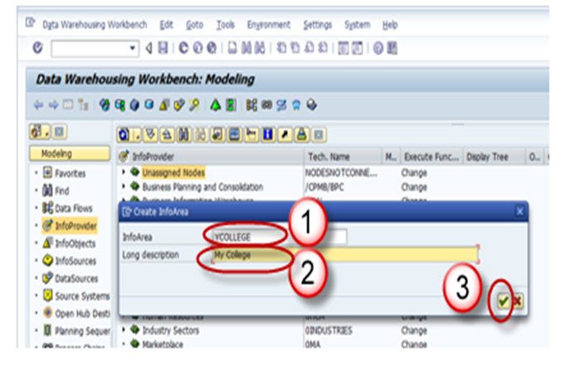

**Step 4)**

The Info Area created appears as shown below.

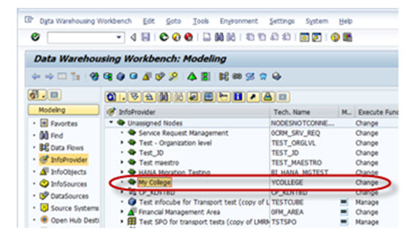

**How To Create an InfoObject Catalog**

**Details**

Last Updated: Sunday, 04 September 2016 16:00

**Step 1)**

1. Go to transaction code RSA1 to go to the Data Warehouse Workbench.
2. Click the OK button.

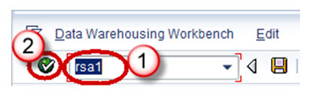

**Step 2)**

1. Navigate to Modeling -> Infoobjects
2. Right click on the Info Area and choose the option “Create InfoObject Catalog” as shown below

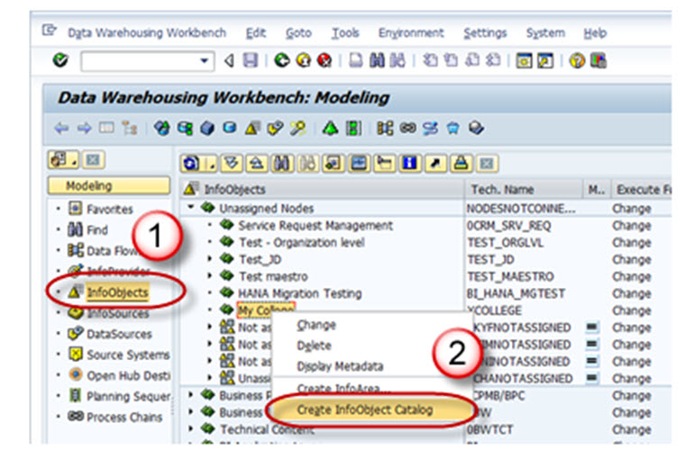

**Step 3)**

1. Enter the Technical name of the InfoObject Catalog.
2. Enter the Description of the InfoObject Catalog.
3. Click in the “Characteristic InfoObject” option button. This is a characteristic InfoObject Catalog. Click the Keyfigure option button. Then a Keyfigure InfoObject Catalog would be created.
4. Click on the create button.

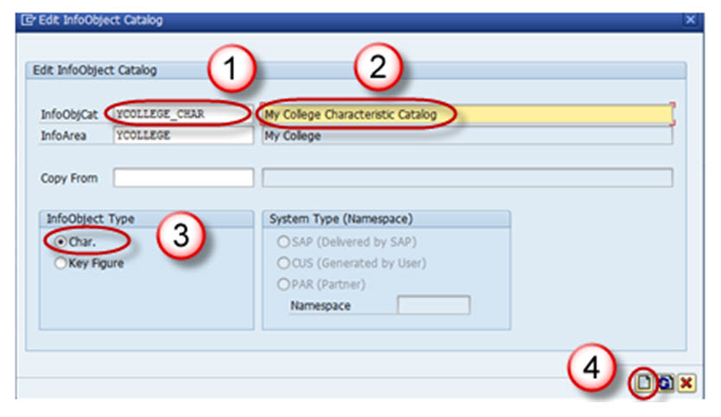

Save and Activate the InfoObject Catalog. The InfoObject Catalog created appears as shown below.

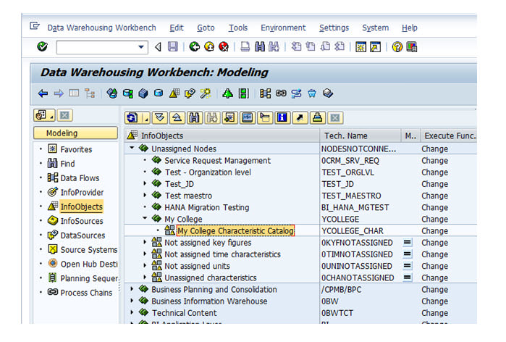

**How To Create an InfoObject with Characteristics**

**Details**

Last Updated: Sunday, 04 September 2016 16:00

**Step 1)**

1. Go to transaction code RSA1 to go to the Data Warehouse Workbench.
2. Click the OK button.

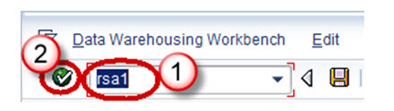

**Step 2)**

1. Navigate to Modeling -> Infoobjects
2. Right click on the Characteristic InfoObject Catalog and choose the option “Create InfoObject” as shown below.

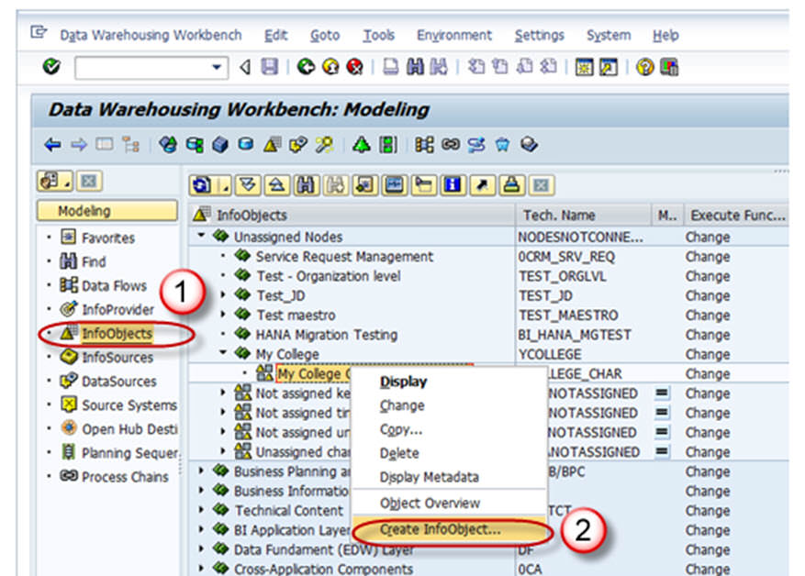

**Step 3)**

1. Give Technical name of the characteristics
2. Give a meaningful Description
3. Reference Characteristics is mentioned if the new characteristic to be created has the same technical properties of some other already existing characteristic.( LCOSTC)
4. Template is specified if the new characteristic to be created has some of the technical properties of an already existing characteristic. (LCOSTC)
5. Hit the enter button.

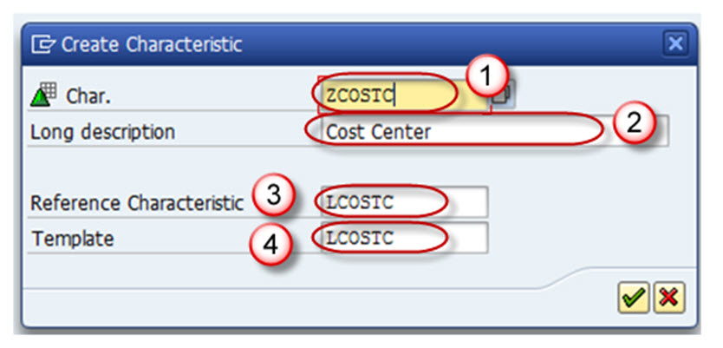

On completion of the above step, it takes you to the “Edit Screen” of the Infoobject. The Infoobject “Edit Screen” has 6 Tab pages listed below.

1. General
2. Business Explorer
3. Master Data/Texts
4. Hierarchy
5. Attribute
6. Compounding

Let us see each of the tab pages individually.

**Tab Page: General**

In this Tab Page, enter the following

1. The Technical name of the InfoObject
2. Enter the long and Short description
3. Enter the data type
4. Enter the length.

All other settings in this tab and other tabs are optional.

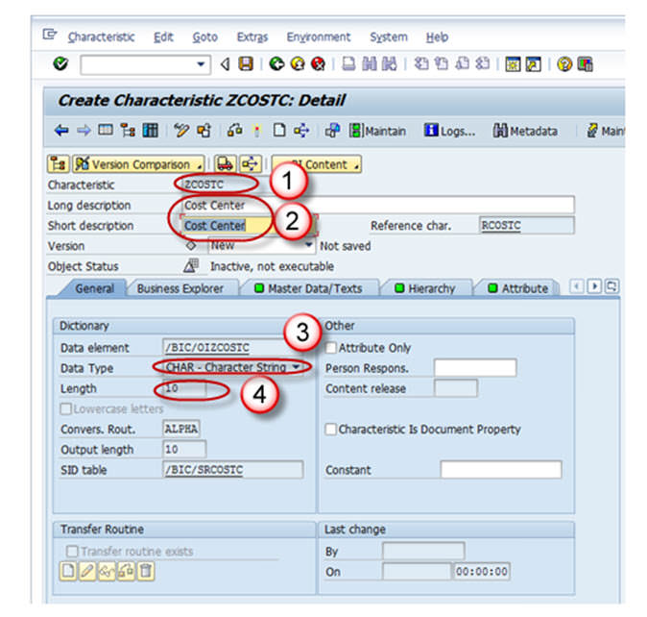

**Tab Page: Business Explorer**

1. Each and every setting in the Business Explorer tab page is to set default values in the Business Explorer.
2. The Display:”Text” setting on this page decides whether the value of the characteristic is displayed as a textual description or as a key in the Business Explorer.

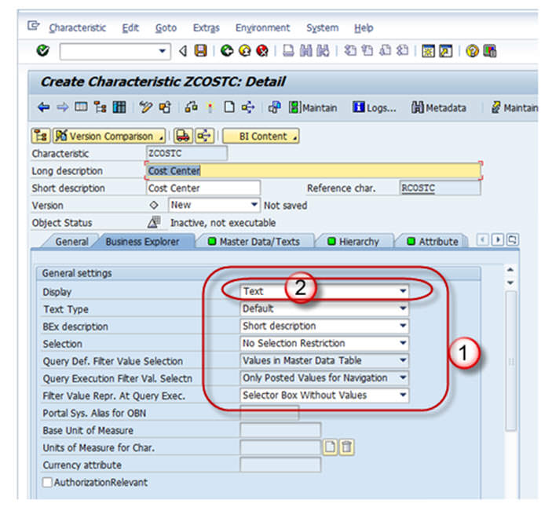

**Tab Page: Master Data/Texts**

1. The Check box “With Master Data checkbox” and/or “With Texts” has to be selected for Master Data bearing Infoobject. By selecting any of these checkboxes, the characteristic is designed to bear master data and it has its own master data tables.
2. If the characteristic needs its own texts, you need to make at least one text selection. The text can be short, medium or long text with 20, 40, or 60 characters respectively.

In the screen shot shown below, the Characteristic has master data table(With master data check box is checked) but does not have Text table(With Texts is unchecked).

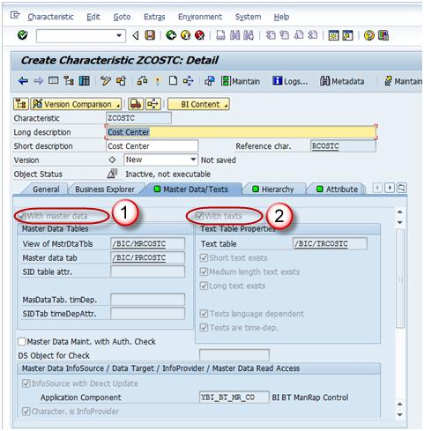

**Tab Page: Hierarchy**

A hierarchy indicates a parent-child relationship which consists of several nodes and leaves.

On the Hierarchy tab page, you determine whether or not the characteristic can have hierarchies and, if so, what properties these hierarchies are allowed to have.

If the **“With” hierarchies** checkbox is checked, hierarchies can be created for this characteristic. In the below screen shot, the check box is unchecked, hence no hierarchy is created for this info object.

Hierarchy can be created manually or loaded from the SAP system or other non sap source systems. Hierarchy can be used to drill down or extract specific information about the business item.

Example: A real time scenario when Hierarchy can be used is as follows,

Assume in the case of a bank, the relationship between the main bank and the various branches under a bank can be maintained in the form of hierarchy. Where you can extract the information of customer details at any branch about its account, loan, due dates for loan payment and so on.

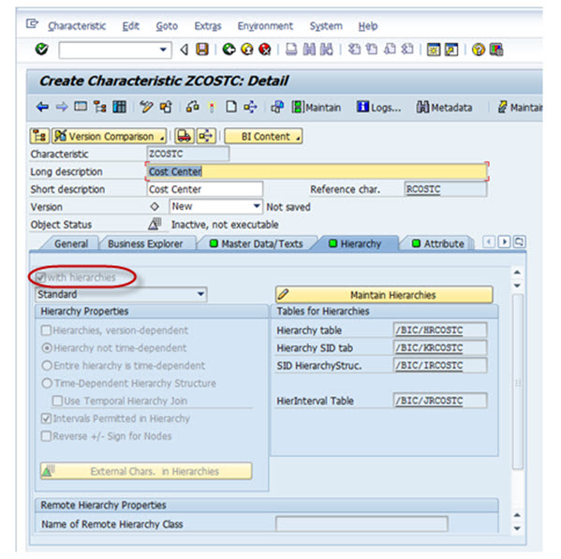

**Tab Page: Attributes**

Attributes are nothing but the fields or properties of master data, there are different types of attributes like display attributes, navigational attributes, executive attributes, compound attributes and so on.

1. You determine whether or not the characteristic can have attributes or texts. The attributes are assigned to the characteristic on the *Attributes* tab page. *Several characteristics can be added as attributes of the master data characteristics in the Attribute tab page.*
2. *Attributes can be marked as navigational or display attribute by clicking on “navigational attribute on/off” button.*

* If you define attributes as **display attributes**, you can use these attributes only as additional information in reporting when combined with the characteristic.
* If you define attributes as **navigation attributes**, you can use them to navigate in reporting. When a query is executed, the system does not distinguish between navigation attributes and characteristics for an InfoProvider.
* In the example below, company code is navigational.

1. Display and navigation attributes can be marked as **time-dependent** if a validity period is required for each attribute value.

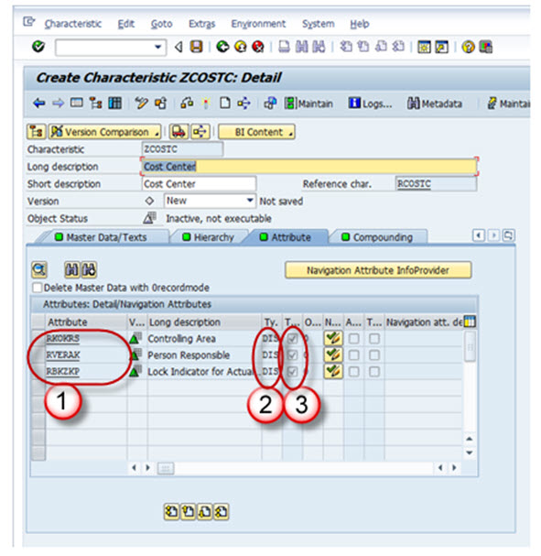

**Tab Page: Compounding**

On this tab page, you determine whether or not the characteristic is to be compounded to other InfoObjects. You often need to compound characteristic values to enable characteristic values to be uniquely assigned. Some Info-objects cannot be defined without compounding, also in order to map the data-model you have to compound Info-Objects sometime. If the info-object is defined as an attributes, it cannot be included as compounding object.

Say, for example, cost center 1000 stands for sales and distribution in controlling area 10, and it also stands for sales in controlling area 20. In this case, you would define a cost center to controlling area characteristic Compounding.

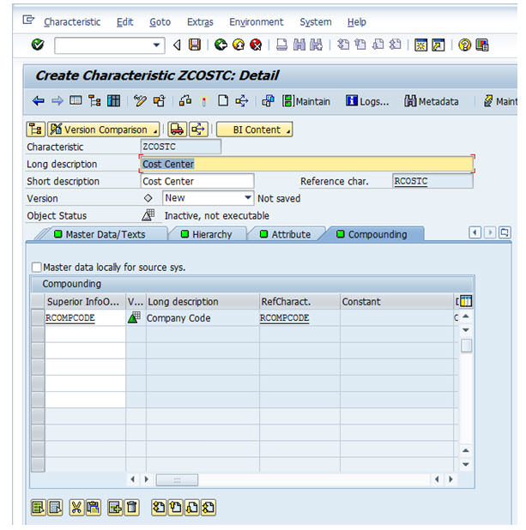

Now save and Activate the Infoobject.

**How To Create InfoObjects With Key Figures**

**Details**

Last Updated: Sunday, 04 September 2016 16:00

Go to RSA1 -> Modeling ->Infoobjects

Right click on the Infoarea -> Click on Create Infoobject catalog for Key Figures. Activate the Keyfigure Infoobject Catalog.

Now Click on Infoobjects catalog -> Create Infoobject

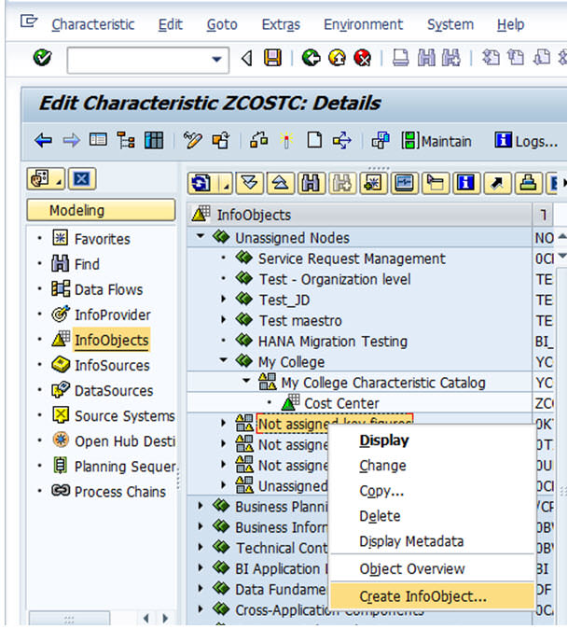

1. Give Technical name of the Keyfigure.
2. Give a meaningful Description
3. Reference Keyfigure is mentioned if the new Keyfigure to be created has the same technical properties of some other already existing Keyfigure. In this case the already existing Keyfigure(Technical name is mentioned here).
4. Template is specified if the new Keyfigure to be created has some of the technical properties of an already existing Keyfigure. In this case the already existing Keyfigure (Technical name is mentioned here).
5. Hit the enter button.

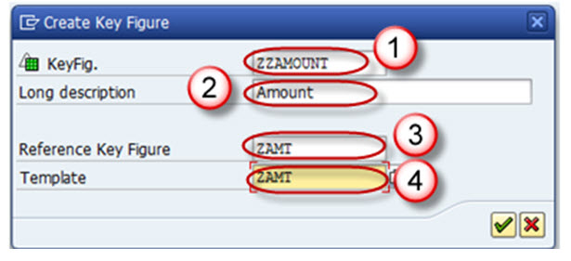

On completion of the above step, it takes you to the Edit screen of the keyfigure Infoobject. The keyfigure Infoobject Edit screen has 3 Tab pages listed below.

1. Type/unit
2. Aggregation
3. Additional Properties

Let us see each of the tab pages individually.

**Tab Page: Type/unit**

1. On this tab page, you determine the key figure type (amount, quantity etc), the data type and the currency/quantity unit.
2. If you choose key figure type amount or quantity, you must assign a currency or quantity unit to this key figure.
3. For key figure type Amount, you can choose between a fixed currency (USD, for example) or a variable currency, (0CURRENCY, for example).
4. For key figure type Quantity, you can choose between a fixed quantity unit such as KG, or a variable quantity unit such as 0UNIT.

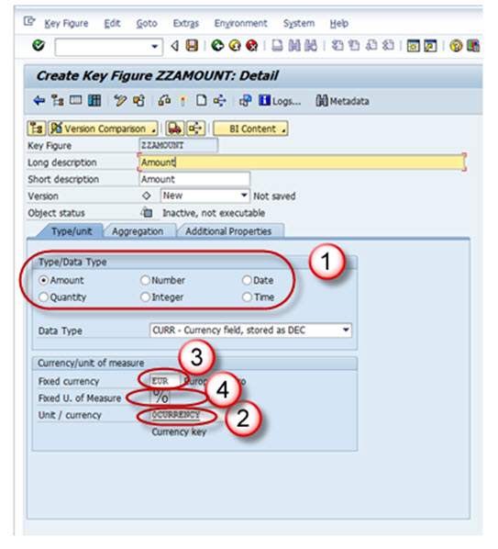

**Tab Page: Aggregation**

An aggregate is a materialized, summarized view of the data in an Infocube. In other words, it consolidates and stores a subset of infocube data into a database.  When query is executed on an infocube with appropriate aggregates the query reads the summarized data directly from the database. It is also referred as baby-cube of Info-cube.  It is recommended to use aggregates, if an infocubes contains lots of data.

Aggregation rules are set on this tab page for the key figure's behavior when data gets stored in tables in BI and in BEx reports.

1. **Aggregation**

In the Aggregation field, you specify the function (SUM/MAX/MIN) that determines the way in which the key figure is aggregated.

1. **Exception Aggregation**

In the Exception Aggregation field, you specify the function (last value, first value, max, or min) that determines the way in which the key figure is aggregated using the reference characteristic for exception aggregation in the Business Explorer.

1. **Reference Characteristic for Exception Aggregation**

In the Reference Characteristic for Exception Aggregation field, you choose the characteristic with reference to which the key figure is aggregated with exception aggregation. Generally, this is a time characteristic.

1. **Cumulative/noncumulative values**

A noncumulative value is a non-aggregating key figure, on the level of one or more objects, that is always displayed in relation to time.

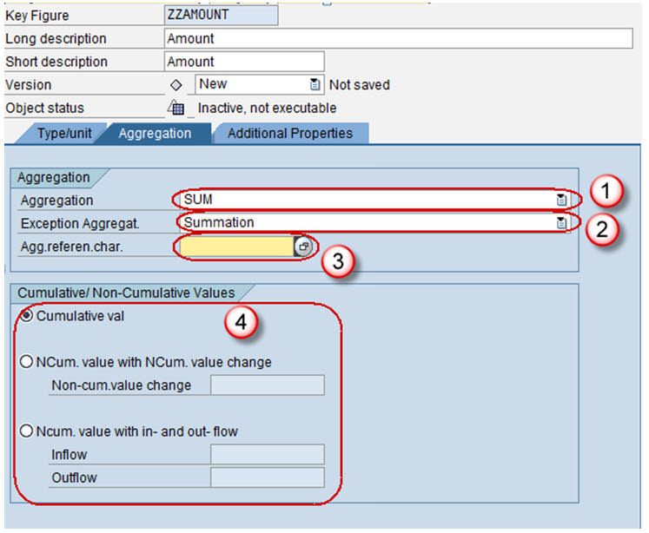

**Tab Page: Additional Properties**

1. This tab page is primarily used to change default settings for the key figure display type (number of decimal places, display scaling etc) in Business Explorer (BEx).
2. It also allows you to set Key Figure with Maximum Precision, which internally processes calculations involving this key figure with more decimal places, thus reducing rounding errors, but at the cost of reduced speed.

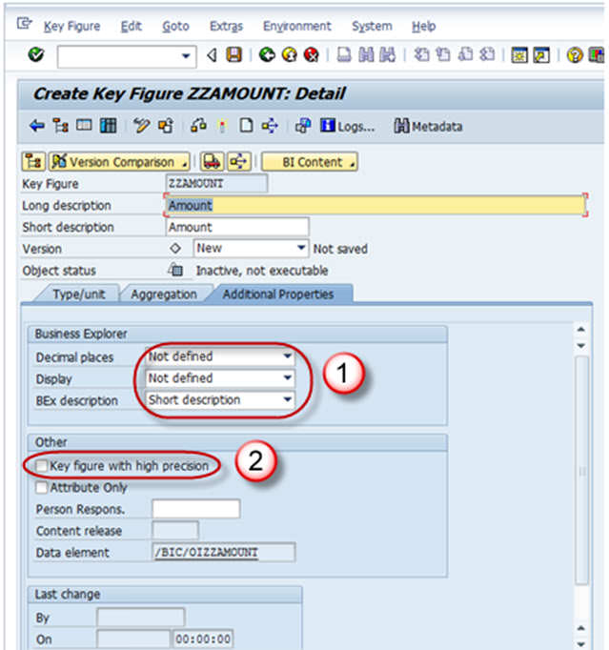

Finally Save and Activate Key Figure.

**What Is DSO? Why Use It?**

**Details**

Last Updated: Sunday, 04 September 2016 16:00

A Data Store object (DSO) is a two dimensional storage unit which mainly stores consolidated and cleansed transaction data or master data on a lowest granularity

* It is a two dimensional Transparent Table.
* Data is stored at detailed level.
* With DSO, it is also possible to overwrite data fields.
* Detailed level reporting can be obtained from a DSO.

**Why use DSO?**

Lets take an example of Sale order Data, which has to be extracted from SAP R/3 system(OLTP: Online Transaction Processing data which keeps changing) into BI. The Sales Orders created in the R/3 system could be edited at any point of time after creation of the record. Initially when sales order records are created in R/3, these records are extracted into BI. Once the records are changed in R/3, the changes need to be made in BI.

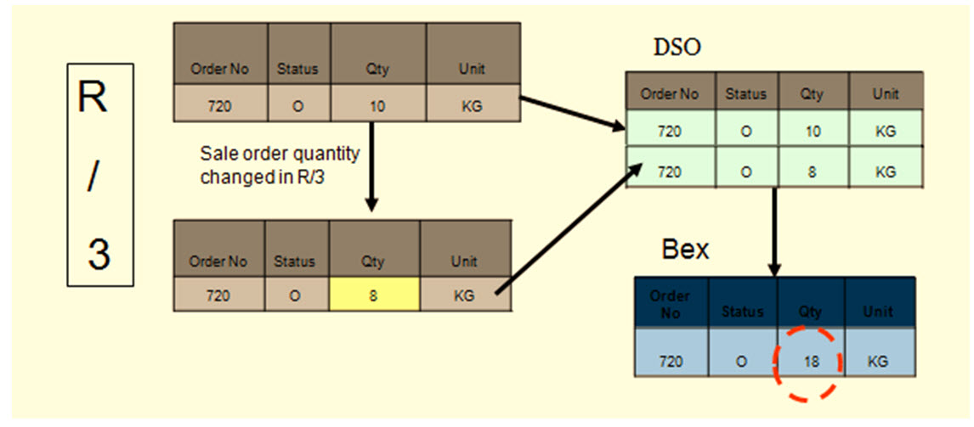

* Data is extracted from SAP R/3 system and loaded into Data Store Object.
* Initially, records are stored in New Status in the DSO. Records are stored in the New Table.
* Once the DSO data is activated, data is stored in the Active table.The New Table does not hold that data anymore.
* When records are changed in R/3, for these changes to reflect in BI, the changes are extracted into the DSO.
* Now the data is stored in the new table until the DSO contents are activated. The Data has to be further loaded into Info cube from which reports are being delivered.
* DSO has Overwrite and additive functionalities.If all characteristics are same, key figures are aggregated/overwritten based on the functionality chosen.
* Cube is additive in nature. If all characteristics are same, key figures are aggregated.

**Types of DSO**

DSOs can be classified into the following types:

1. Standard DSO
2. Direct Update DSO
3. Write-Optimized DSO

**What Is Standard DSO? How To Create One?**

**Details**

Last Updated: Sunday, 04 September 2016 16:00

A standard DSO has three transparent tables on the database.

1. **Activation Queue**: Holds the records that are to be updated, not yet been activated.
2. **Active Data:**Table which holds active data.
3. **Change Log:**Holds the change history for delta loads.

**Process of Data transfer to DSO**

* Data gets first loaded into the activation Queue also called the New data table.
* Dataupon “Activation” is transferred from New data table to Active data table
* And then to Change log table. In change log table you can have the changed data or corrected data.

Note: the data in Change log table is redundantly stored and can be deleted after the records have been activated.

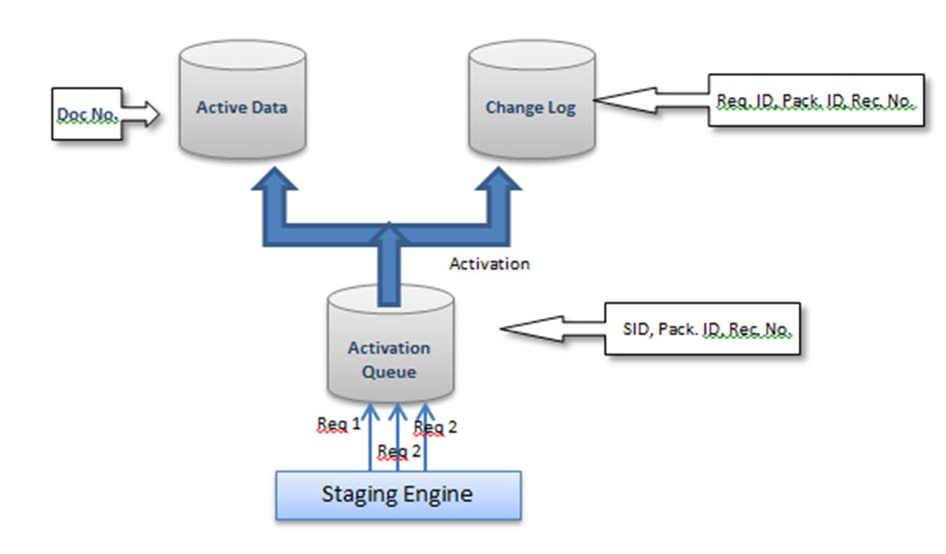

**Creation Of Standard DSO:**

**Step 1)**

1. Go to transaction code RSA
2. Click the OK button.

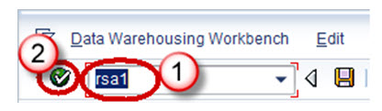

**Step 2)**

1. Navigate to Modeling tab->InfoProvider.
2. Right click on InfoArea.
3. Click on “Create DataStore Object” from the context menu.

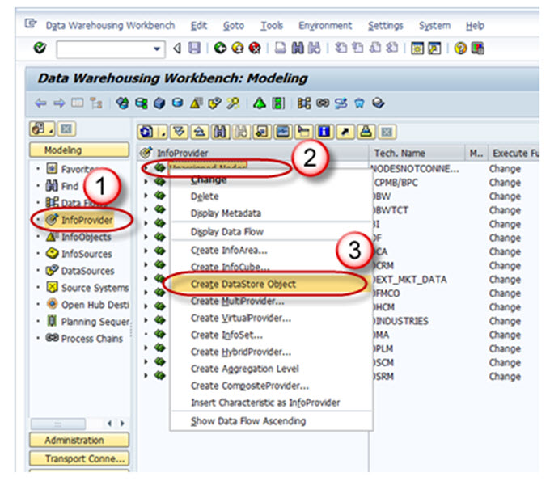

**Step 3)**

1. Enter the Technical Name.
2. Enter the Description.
3. Click on the “Create” button.

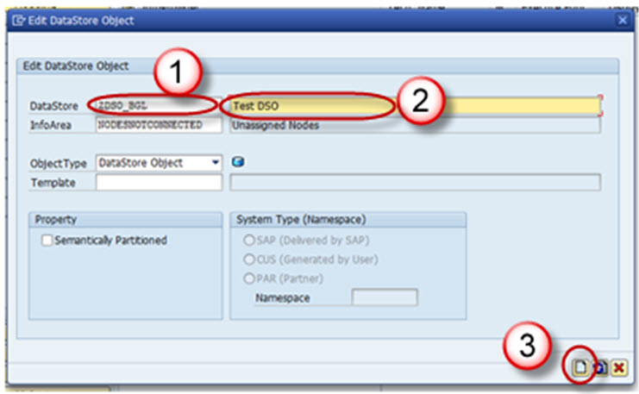

**Settings in DSO:**

1. Type of DataStore Object: This option can be used to change the type of DSO. By default, Standard DSO would be chosen. This can be changed to Write optimized or Direct Update DSO.
2. SID Generation upon Activation :Generated the Surrogate ID (SID) for each master data value, when this option is checked.
3. Unique Data Records:  This option can be used when the DSO will never hold duplicate values.
4. Set Quality Status to “OK” Automatically:  This setting sets the Quality status after the data loading has been completed.
5. Activate Data Automatically: DSO activation is automated by using this setting.
6. Update Data Automatically: Data loaded in the DSO can be automatically loaded to target objects using this setting.

**Including Key Fields and Data Fields in the DSO:**

DSO contains 2 kinds of fields

1. Key field
2. Data field

Key field is used to make the records unique. Other fields can be included as data fields in the DSO,

**Step 1)**

Right Click on “Key fields” and choose the option “InfoObject Direct Input”.

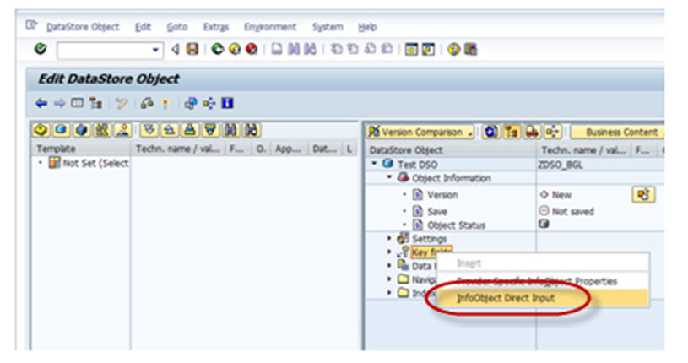

**Step 2)**

The following pop-up opens. Here you can input the technical names of the InfoObjects you have to include and press enter.

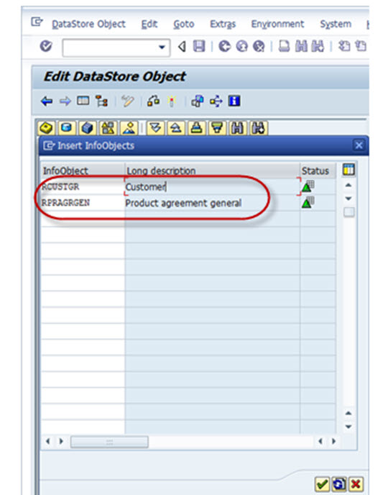

Below shown is the Keyfields added in the DSO.

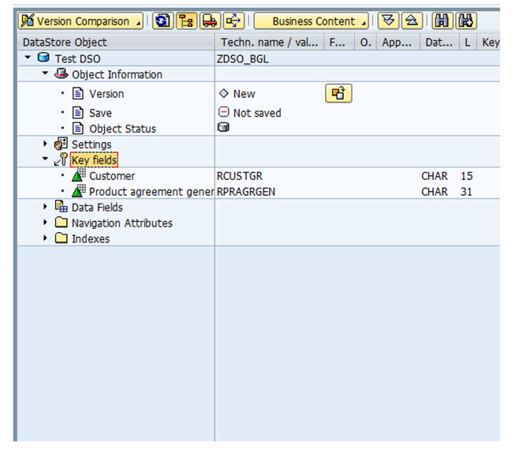

**Step 3)**

Navigational Attribute would be viewed in the DSO by default, but the check box to ON/OFF Navigational has to be chosen if it is to be used in reporting.

**Step 4)**

The DSO structure design is complete. Activate the DSO by clicking on the Activate button.

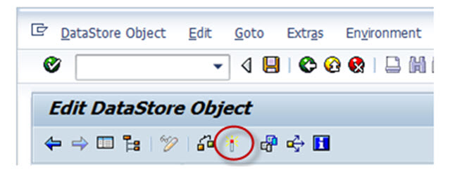

**What Is Write Optimized DSO? How To Create One?**

**Details**

Last Updated: Sunday, 04 September 2016 16:00

Write Optimized DSO is used when a Data storage object is required for storing lowest granularity records such as address and when overwrites functionality is not needed. It consists of the table of active data only, hence no need for data activation which increases data process. Data store object is available immediately for further processing; it is used as a temporary storage area for large set of data.

Write-Optimized DSO has been primarily designed to be the initial staging of the source system data from where the data could be transferred to the Standard DSO or the Info Cube.

1. PSA receives data unchanged to the Source system
2. Data is posted at document level**,** After loading in to standard DSOs data is deleted
3. Data is posted to Corporate memory write –optimized DSO from pass thru write-optimized DSO
4. Data is Distributed from write-optimized “pass thru” to Standard DSOs as per business requirement

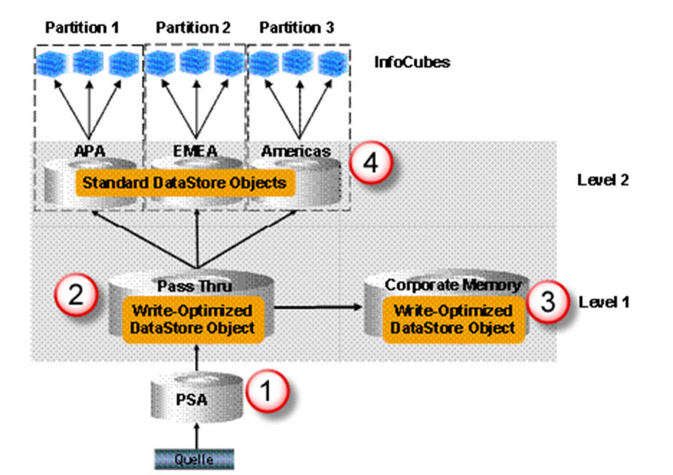

**Write Optimized DSO Properties:**

* It is used for initial staging of source system data.
* Data stored is of lowest granularity.
* Data loads can be faster since it does not have the separate activation step.
* Every record has a technical key and hence aggregation of records is not possible. New records are inserted every time.

**Creation Of Write-Optimized DSO:**

**Step 1)**

1. Go to transaction code RSA1
2. Click the OK button.

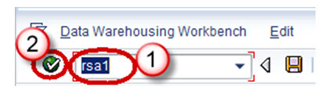

**Step 2)**

1. Navigate to Modelling tab->Info Provider.
2. Right click on Info Area.
3. Click on “Create Data Store Object” from the context menu.

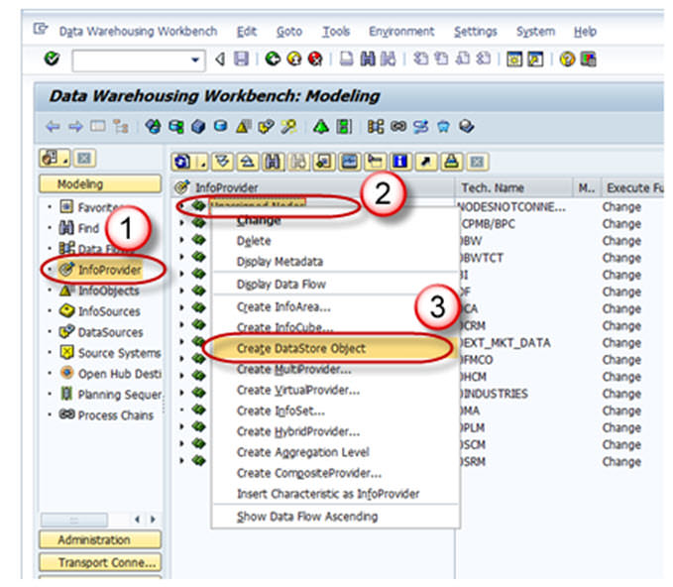

**Step 3)**

1. Enter the Technical Name.
2. Enter the Description.
3. Click on the “Create” button.

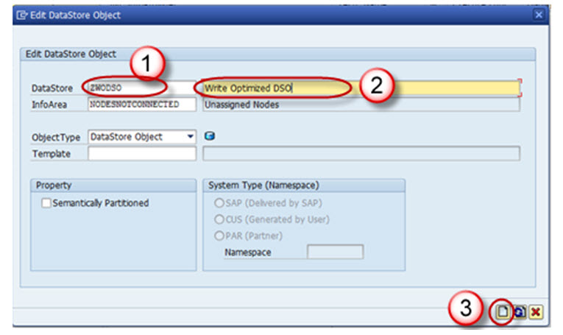

**Step 4)**

Click on the Edit button of “Type of DataStore Object”.

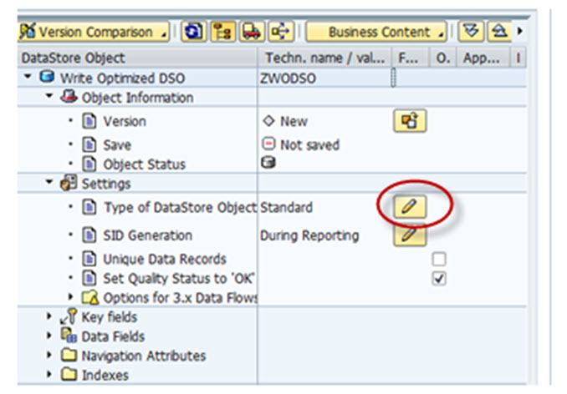

**Step 5)**

Choose the Type “Write-Optimized”.

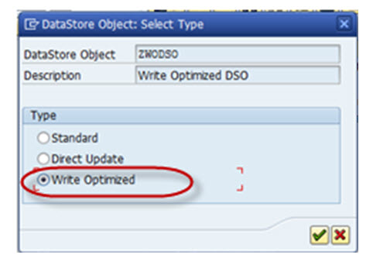

Technical keys include Request ID, Data package, Record number. No additional objects can be included under this.

Semantic keys are similar to key fields, however, here the uniqueness is not considered for over write functionality. They are instead used in conjunction with setting *“Do not check uniqueness of data”.*

The Purpose of Semantic Key is to identify error in incoming records or Duplicate records .

Duplicate Records are written into error stack in the subsequent order. These records in the error stack can be handled or re-loaded by defining Semantic Group in DTP.

Semantic Groups need not be defined if there will be no possibility of duplicate records or error records.

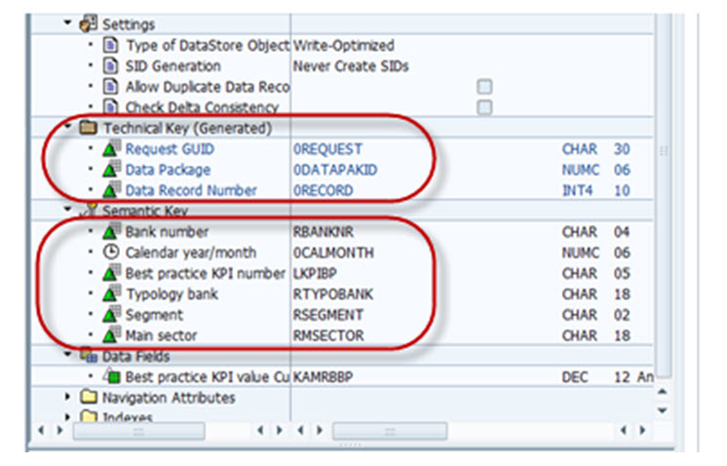

If we do not check the Check Box  “Allow Duplicate Data Record “, the data coming from source is checked for duplication, i.e, if the same record (semantic keys) already exist in the DSO, then the current load is terminated.

If we select the check box , Duplicate records are loaded as a new record. There is no relevance of semantic keys in this case.

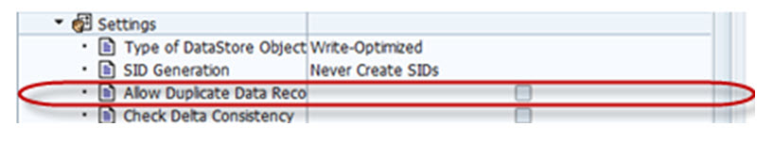

**Step 6)**

Activate the DSO.

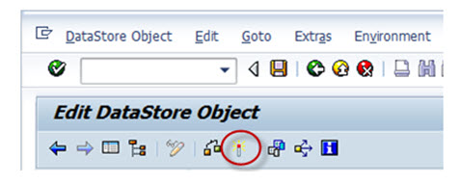

**What Is Direct Update DSO? How To Create One?**

**Details**

Last Updated: Sunday, 04 September 2016 16:00

Standard DSO differs from Direct update DSO in terms of how data is processed.

In Standard DSO, data is stored in different versions Active, Delta, Modified

whereas Direct Update DSO contains data in single version. Data is stored precisely in same form in which it is written to DSO consists of Active Data Table for direct update by the application. It retrieves its data from external systems via fill or delete APIs.

**The Following APIs exists:**

* RSDRI_ODSO_INSERT: This API is used to Insert new data which does not exist in the system.
* RSDRI_ODSO_INSERT_RFC: This is similar to the API “RSDRI_ODSO_INSERT” except that this API can be called remotely.
* RSDRI_ODSO_MODIFY:  This API is used to modify existing records. If a new record comes in, the record is inserted.
* RSDRI_ODSO_MODIFY_RFC: This is similar to the API “RSDRI_ODSO_MODIFY” except that this API can be called remotely.
* RSDRI_ODSO_UPDATE: This API is used to modify existing records.
* RSDRI_ODSO_UPDATE_RFC: This is similar to the API “RSDRI_ODSO_UPDATE” except that this API can be called remotely.
* RSDRI_ODSO_DELETE_RFC: This API is used to delete records.

**Direct Update DSO – Properties**

* DSO for direct update contains data in a single version. Therefore, data is stored is in precisely the same form in which it was written by the application
* Records with the same key are not aggregated
* SIDs cannot be generated
* Data from it can be updated to additional info providers.
* The DSO for direct update is available as an Info Provider in BEx Query Designer and can be used for analysis purposes.
* It is an additional function that can be used in special application contexts.
* To load data quickly without using the extraction and load processes in the BI system.
* Can be used as data target for an analysis process.

**Direct Update DSO – Functionality**

* Can Update the Direct Update DSO data in to additional info providers.
* Can be used as an info provider for Bex Query Designer and can be used for analysis process.

**Advantage:**

* It is structured in a way to access data easily.
* Data is made available for analysis and reporting immediately after it is loaded.

**Drawbacks**

* The loading process is not supported by the BI system (Data Sources do not provide the data).
* Therefore DSOs are not displayed in the administration or in the monitor.
* Since a change log is not generated, we cannot perform a delta update to the Info Providers.

**Creation Of Direct Update DSO:**

**Step 1)**

1. Go to transaction code RSA1
2. Click the OK button.

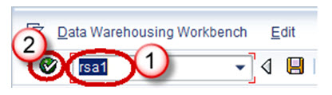

**Step 2)**

1. Navigate to Modelling tab->Info Provider.
2. Right click on Info Area.
3. Click on “Create Data Store Object” from the context menu.

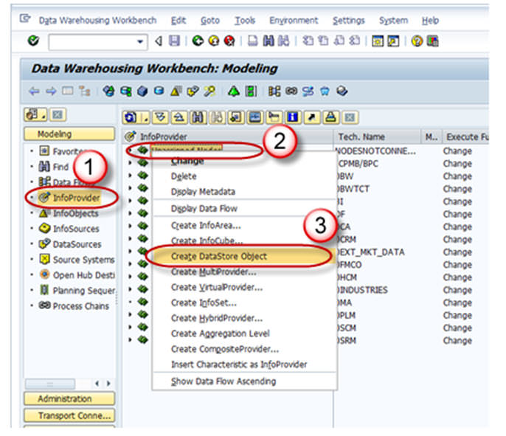

**Step 3)**

1. Enter the Technical Name.
2. Enter the Description.
3. Click on the “Create” button.

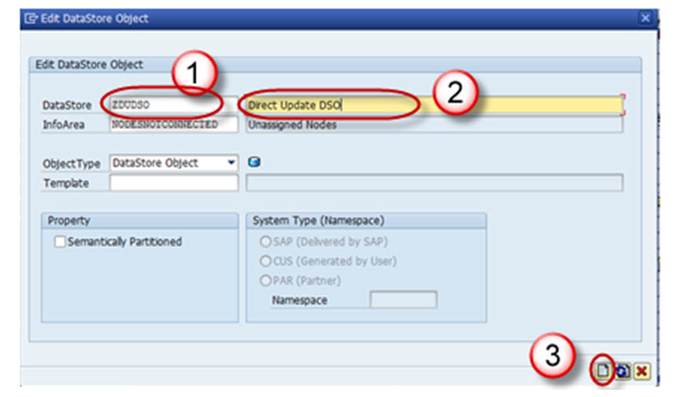

**Step 4)**

Click on the Edit button of “Type of DataStore Object”.

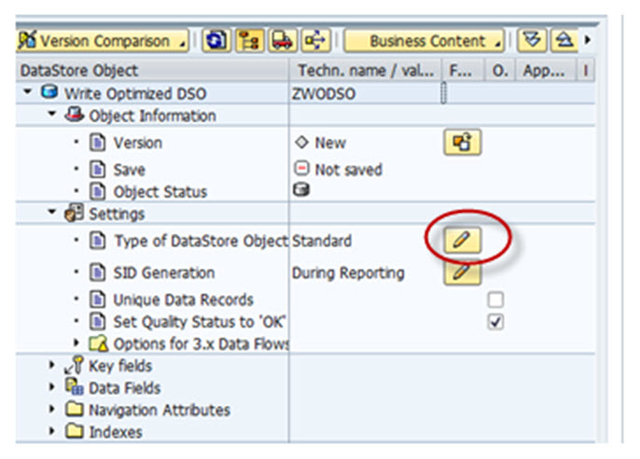

**Step 5)**

Choose the Type “Direct Update”.

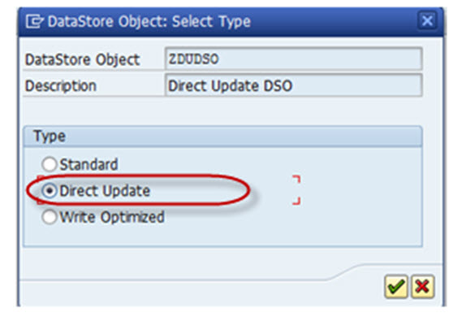

**Step 6)**

Activate the DSO.

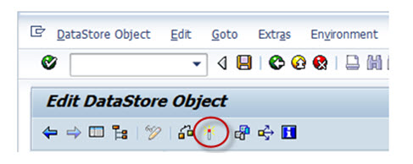

**What is InfoSet?**

**Details**

Last Updated: Sunday, 04 September 2016 16:00

Infoset is a special kind of Infoprovider which does not store data physically. In other words, Infoset are InfoProviders that logically join data and provide this data for BI queries. Infoset collects data from the tables of InfoProviders used to build it.  Infoset describes data sources that are defined as a rule of join on Datastore objects, Info-objects or standard InfoCubes.

**When to Use Infosets?**

* To join required data from basic InfoProviders
* To allow BEx Reporting on a DataStore object without turning the BEx Reporting indicator on
* To evaluate time dependencies
* To create self joins and left outer joins

**What are InfoSet Joins ?**

DSO ( Data Store Objects) and/or InfoObjects (characteristics with master data) are connected in the InfoSet using join conditions. The joined data from the InfoSets are available for access from Business Explorer Queries. InfoSets allows you to report on several Info-Providers (Infocubes, Data Store objects, master data InfoObjects), but they contain no data. With activated Infosets , you can define queries in the BI suite.

**Joins are classified into four categories:**

1. Inner Join
2. Left Outer Join
3. Temporal Join
4. Self Join

**Inner Join:**A record can only be in the selected result set if there are entries in both joined tables.

If table 2 has corresponding records of table 1, by comparing a key field (EMPNO in the below example), only those records would be part of the result set. The result set would have the fields of table 1 and table 2 filled in from the corresponding fields.

Example:

**Left Table(Table 1)**

|  |  |
| --- | --- |
| EMPNO | LASTNAME |
| 000020 | THOMPSON |
| 000250 | SMITH |
| 000100 | SPENSER |

**Right Table(Table 2)**

|  |  |
| --- | --- |
| EMPNO | PROJNO |
| 000020 | AD3112 |
| 000100 | OP2010 |
| 000150 | PL2100 |

**Inner Join Result**

|  |  |  |
| --- | --- | --- |
| EMPNO | LASTNAME | PROJNO |
| 000020 | THOMPSON | AD3112 |
| 000100 | SPENSER | OP2010 |

**Left Outer Join:**If table 2 has corresponding records of table 1, by comparing a key field (EMPNO in the below example), those records would be part of the result set. The result set would have the fields of table 1 and table 2 filled in from the corresponding fields.

If table 2 has no corresponding record when compared with table 1, those records of table 1 is also part of the result set (fields belonging to table 2 will have initial values). This is shown in the example below.

**Left Table(Table 1)**

|  |  |
| --- | --- |
| EMPNO | LASTNAME |
| 000020 | THOMPSON |
| 000250 | SMITH |
| 000100 | SPENSER |

**Right Table(Table 2)**

|  |  |
| --- | --- |
| EMPNO | PROJNO |
| 000020 | AD3112 |
| 000100 | OP2010 |
| 000150 | PL2100 |

**Left Outer Join Result**

|  |  |  |
| --- | --- | --- |
| EMPNO | LASTNAME | PROJNO |
| 000020 | THOMPSON | AD3112 |
| 000250 | SMITH |  |
| 000100 | SPENSER | OP2010 |

**Temporal Join:** A join is called temporal if at least one member is time-dependent.

**Self Join:** The same object is joined together.

**Creation Of Infoset:**

**Step 1)**

1. Go to Transaction Code RSA1
2. Click the “Ok” button

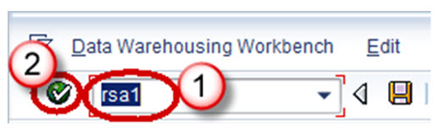

**Step 2)**

1. Browse to the tab “InfoProvider”
2. Right-Click on the infoarea and choose the option “Create Infoset” from the context menu.

Transaction RSISET can also directly be used to create InfoSet.

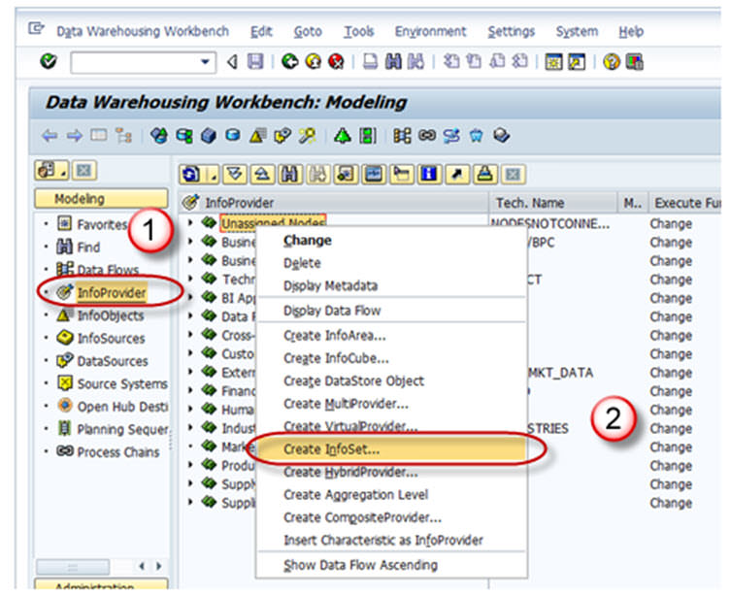

When the Info Set Builder is called for the first time, the below two display mode options as

1. Network (Dataflow Control)
2. Tree (Tree Control).

The network display is clearer.

The tree display can be read by the Screen Reader and is suitable for visually-impaired users.

You can change this setting at any time using the menu path Settings -> Display.

**Step 3)**

1. Enter the Technical Name
2. Description
3. In the *Start with Info Provider* section, you determine which Info Provider you want to use to start defining the Info Set. Select one of the object types that the system offers you:

* Data Store object
* Info Object
* Standard Info Cube
* Choose an object.

If you want to choose an Info Object, it must be a characteristic with master data. The system provides you with the corresponding input help.

1. Choose Continue button.

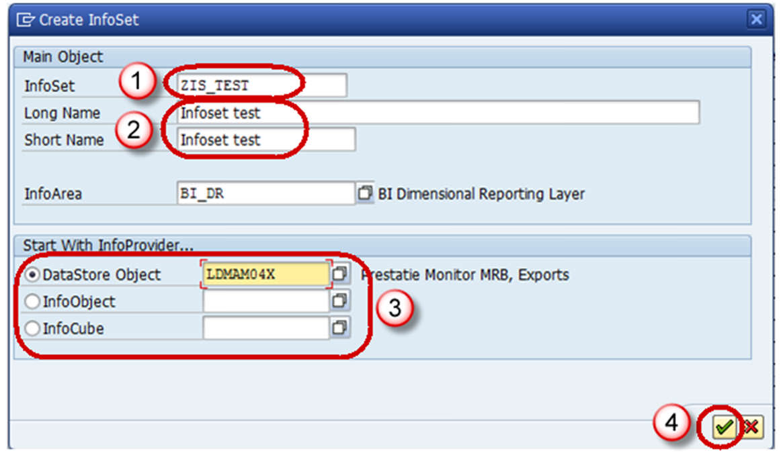

**Step 4)**

The *Change Info Set* screen appears.

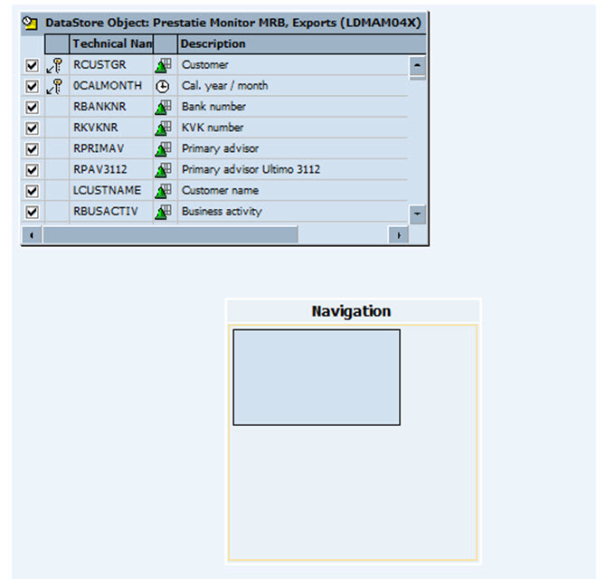

**Step 5)**

Select the insert Info provider button shown below, to choose the infoprovider with which data is to be joined.

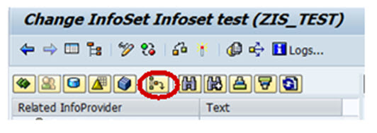

**Step 6)**

1. Enter the name of the DSO.
2. Click Continue button.

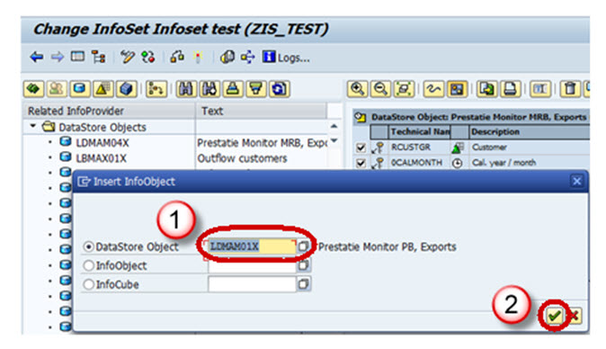

The below screen appears with the 2 info providers selected.

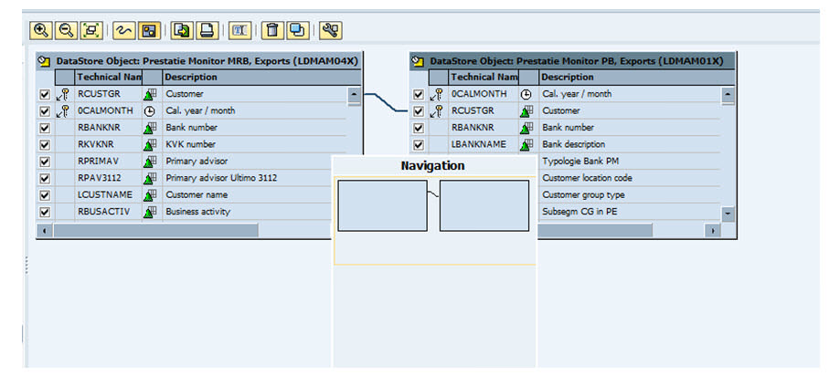

**Step 7)**

Activate the Info set by clicking on the activate button.

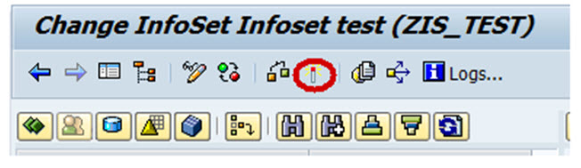

**What Is an Infocube? How To Create One?**

**Details**

Last Updated: Sunday, 04 September 2016 16:00

**What is Infocube?**

Infocube is data storage area in which we maintain data which we are extracting from source system physically.  An InfoCube can function as both a data target and an InfoProvider. From a reporting point of view, an Infocube can be described as a self-contained dataset.

For example, a Sales Amount Infocube which has dimensions like MONTH – PRODUCT-CUSTOMER-REGION, can be viewed by any of the axes, for example total sales by region or by customer. The dimensions of an Info-Cube are entities or hierarchies.

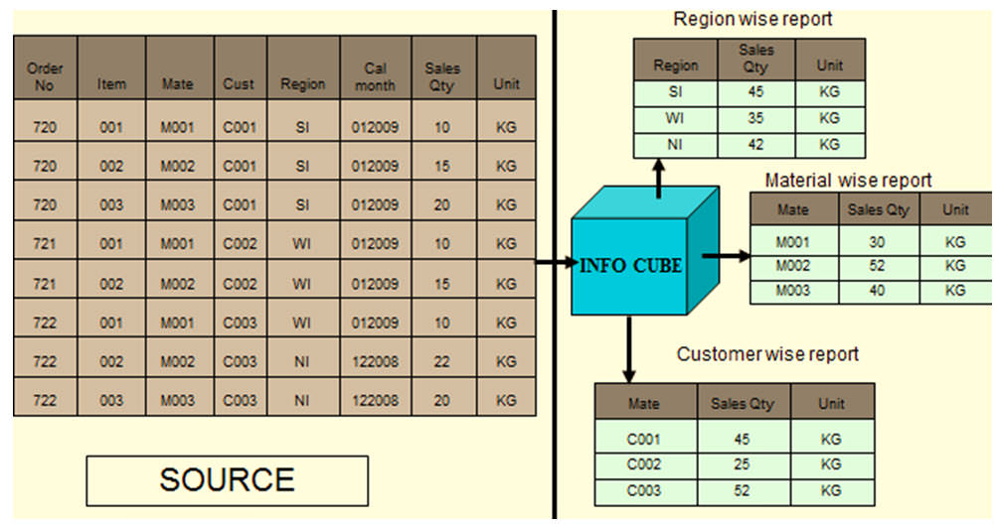

BIW ( Business Intelligence Warehouse) provides facility to define 16 dimensions, out of which 3 are pre-defined.

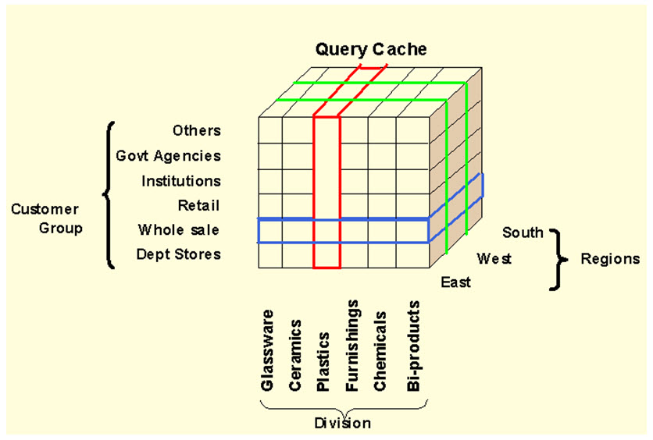

The above cube demonstrates a simple 3 dimensional cube. Each dimension can hold 248 characteristics for analysis. One square in the cube above, represents the relative value for the corresponding customer/region/division combination.

**InfoCube Structure:**

* An Infocube follows the Extended Star Schema.
* It has Fact table at the center and is surrounded by 16 dimension tables with Master data lying outside the cube.
* Infocubes are the central multidimensional data model in BI.
* It is a self-enclosed data set encompassing one or more related business processes. A reporting user can define or execute queries against an info cube.
* It is used to store summarized / aggregated data for long periods of time. Infocubes consist of precisely one fact table surrounded by dimensional tables.
* SAP delivered Infocubes begins with a number usually 0. Your own Infocube should begin with a letter from A to Z and that it should be 3 to 9 characters in length.

**Type of InfoCube**

Infocube is classified in to three types based on the way of maintaining and distributing the data.

* **Standard Infocube:**Used to maintain the data physically in the cube. Read only is possible.
* **Virtual Infocube:** It does not maintain data physically in the cube .During the query execution it brings the data from respective source system.
* **Real Time Infocube:** Stores the data physically in the cube.Read and Write are possible. It is significantly used in planning the data.

**How To Create  Standard Infocube**

**Step 1)**

Create InfoCube

1. Go to transaction code RSA1
2. Click the OK button.

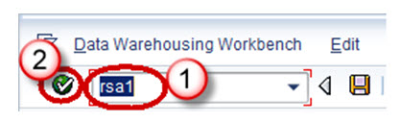

**Step 2)**

1. Navigate to Modeling tab->InfoProvider.
2. Right click on InfoArea.
3. Click on “Create InfoCube” from the context menu.

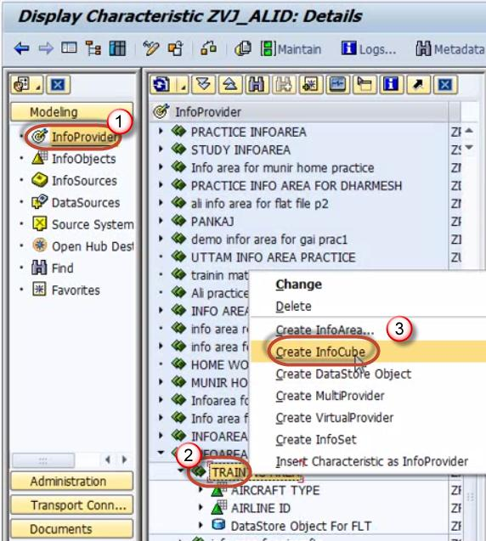

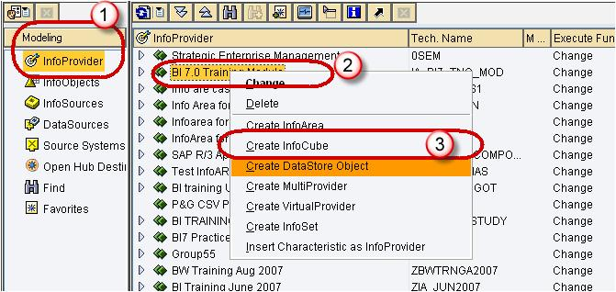

**Step 3)**

1. Enter the Technical Name.
2. Enter the Description.
3. Choose the option button “Standard InfoCube”.

Click the create button

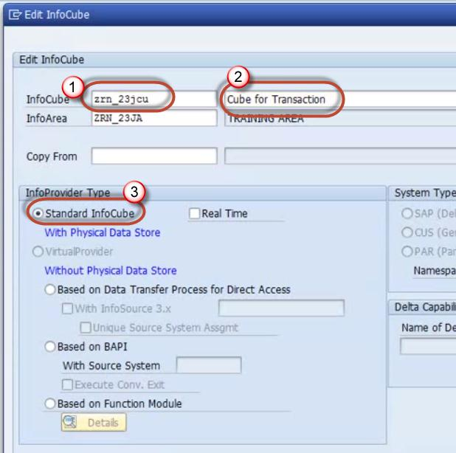

**Step 4)**

Right Click on Dimension 1 -> Properties.

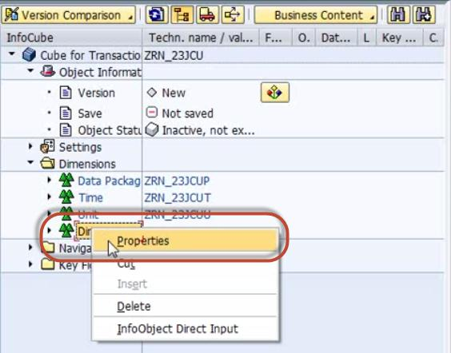

**Step 5)**

Rename the Dimension as per Info object information.

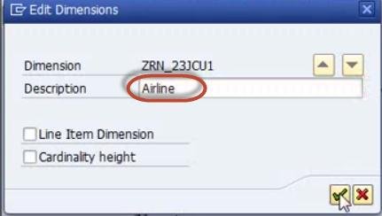

**Step 6)**

Right click on the Dimension ->InfoObject Direct Input to Insert InfoObjects into the Dimension.

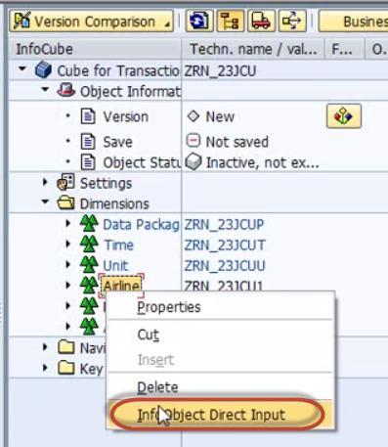

**Step 7)**

Select Characteristics.

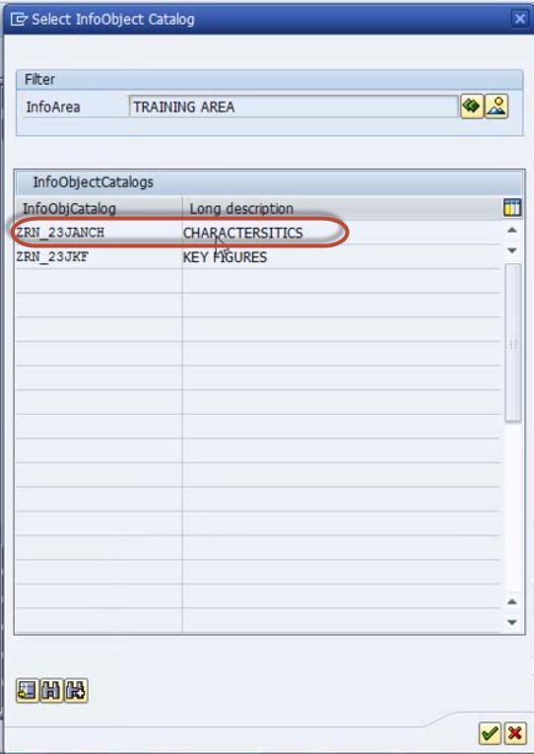

**Step 8)** Select Airline ID in characteristics

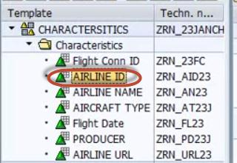

Drag and drop it into Dimension

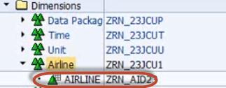

**Step 9)**

Similarly create new dimensions and follow the steps 4-8 to add the InfoObjects.

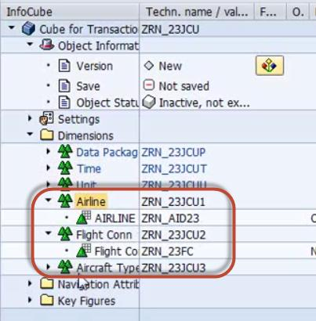

**Step 10)**

Adding Key figureInfoObjects in the Infocube

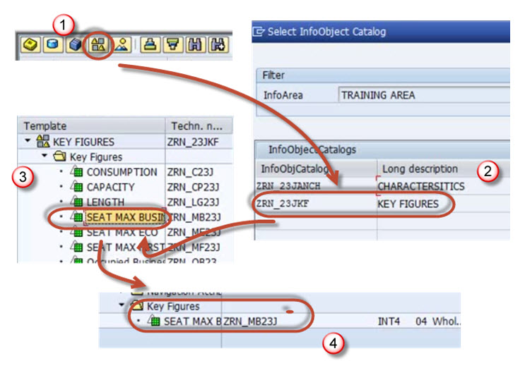

**Step 11)**

Follow the proesses above to add more Key Figures

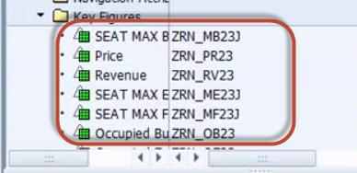

**Step 12)**

Activate the Infocube.

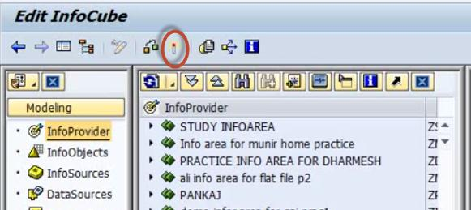

**Infocube Additional Points:**

The technical name of the dimensional table is assigned by the system, using the pattern /BIC/ “D<your Infocube>#”, where the first # will be a1, the second a 2, and so on*.*

If it is a sap delivered cube, then it would begin as /BI0/D

Characteristics Infoobjects can be freely added to customer-created dimensions.

Dimension Tables should be used optimally.

Ensure optimum cardinality while adding characteristics infoobject to dimensions.E.g. *A departmental store has 10,000 customers and 1000 different materials. The cardinality is* ***m:n****, which means each customer can buy many materials. Such kind of cardinality should not be maintained in the same dimension table.*

*Thumbrule : Avoid m:n within a dimension.*

**Dos**

* Navigate to Modeling tab->InfoProvider.
* Right click on InfoArea.
* Click on “Create InfoCube” from the context menu.
* Enter the Technical Name.
* Enter the Description.
* Choose the option button “Standard InfoCube”.

**Don’ts**

* Standard Infocube can be used if user:
* Wants to facilitate multi-dimensional analysis.
* Wants to store summarized / aggregated information with large volume of data.
* Use line item dimension if only one object is placed in a dimension table.
* Maintain high granularity of records.
* Group M: N cardinality within the same dimension.
* Give more attention on bring the character information through navigational attribute.
* Maintain high cardinality information in dimensional table.

**How To Load Master Data From Flat File?**

**Details**

Last Updated: Sunday, 04 September 2016 16:00

**We will learn the load with the help of a scenario -**

Load Master data to InfoObject ZMAT (Material Number) which has the attribute, ZMAT_NM (Material Name. Below are detailed Steps to Load data to Master data Infoobject from Flat file

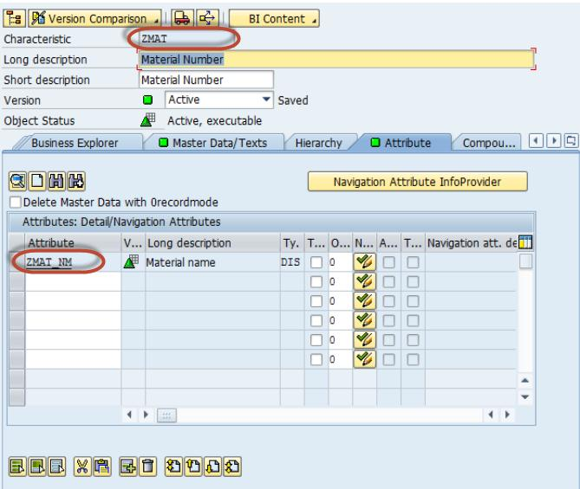

**Step 1)  Create source system for flat file**.

1. Go to transaction code RSA1
2. Click the OK button.

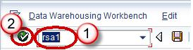

In the next screen,

1. Navigate to Modeling tab->Source Systems.
2. Right click on the folder named FILE and choose “Create” from the context menu.

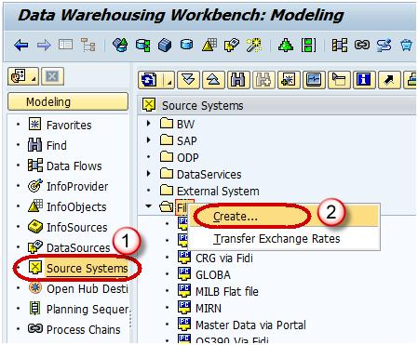

In the next screen,

1. Enter the Logical System Name.
2. Enter the Description.
3. Click Continue Button.

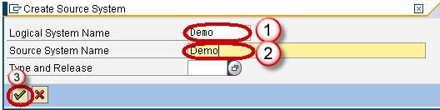

**Step 2) Create Application component.**

1. Navigate to Modeling tab->Data Sources.
2. Choose the Source System.

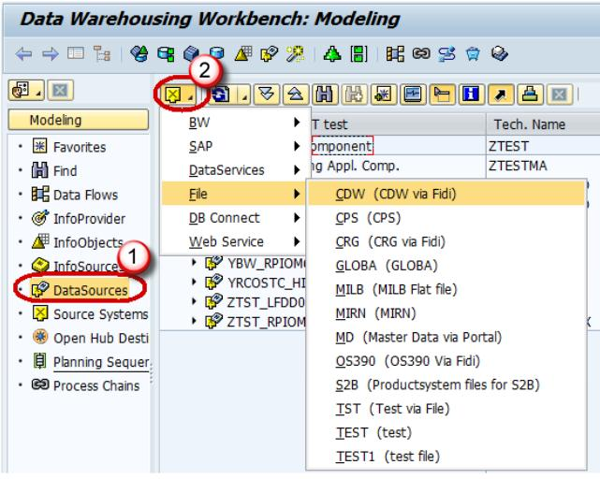

1. Right click -> Create Application Component.

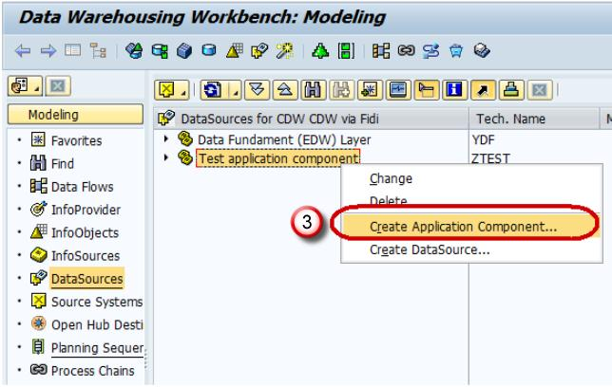

1. Enter the Technical Name.
2. Enter the Description.
3. Click Continue.

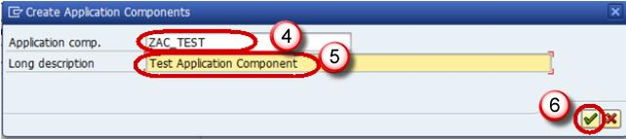

1. Navigate to Modeling tab->Data Sources.
2. Right click -> Create Data Source

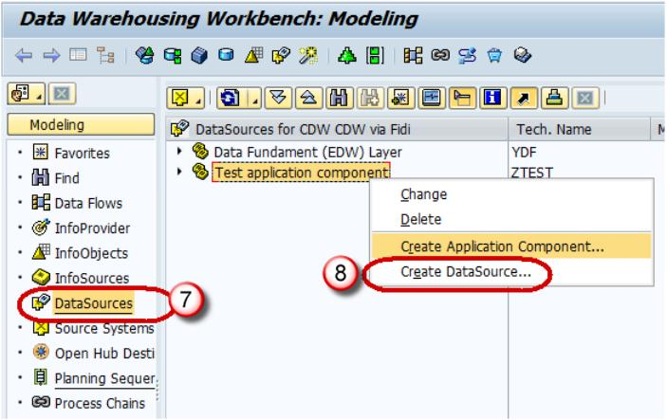

1. Enter Technical Name.
2. Choose the DataType DataSource.
3. Click Continue.

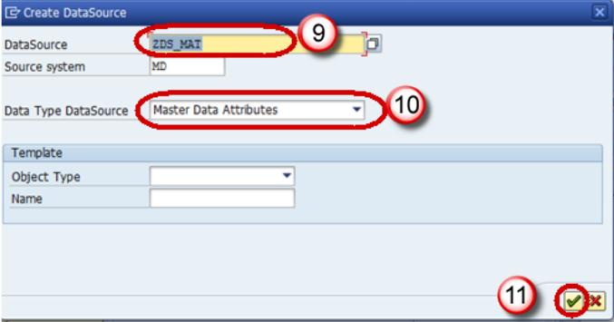

1. Enter the Fields shown below. This Structure should be the same as the DSO to which transaction data is to be loaded.

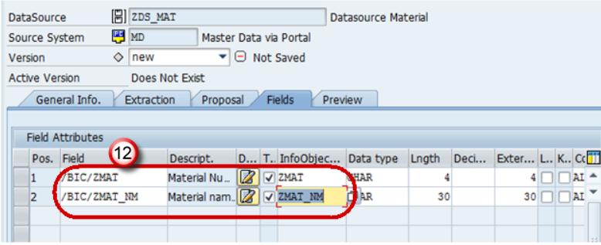

1. In the Extraction tab, choose the Adapter as “Load Text-Type File from Local Workstation”.
2. Choose the file path where the flat file to be loaded is placed in the system and activate data source.

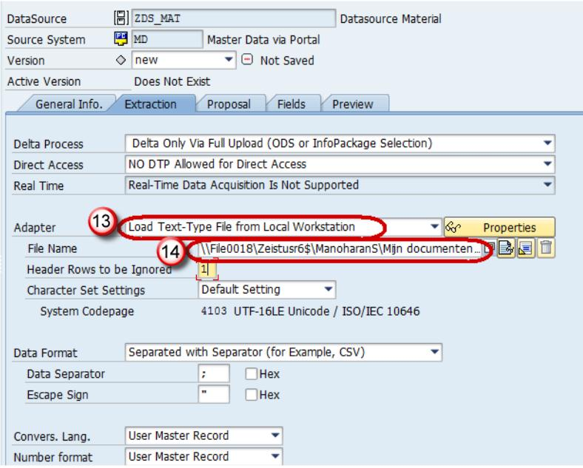

Click Save.

**Step 3) Create transformation between Data Source(Source) and InfoObject Attribute(Target).**

Right click on the DataSource -> Create Transformation

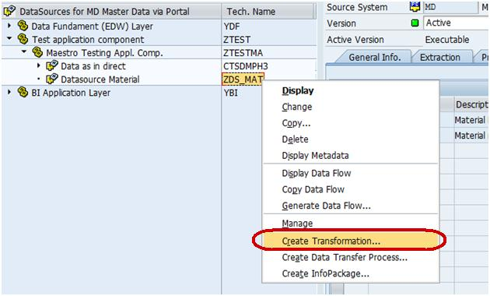

In the next screen,

1. Enter Target Object Type.
2. Enter Target Object Name.
3. Enter the SubType
4. Click Continue.

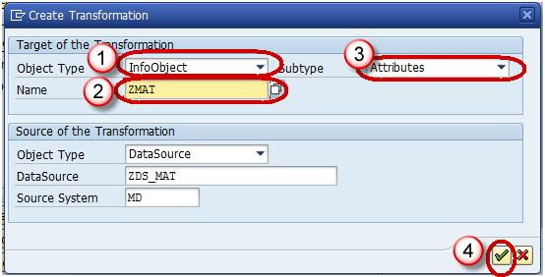

The transformation would be created with automatic mapping of the Source fields to the Target fields.

Right-Click on DTP folder and choose the option “Create Data Transfer Process” from the context menu.

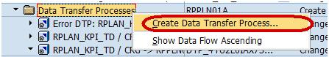

Below screen shows the DTP created.

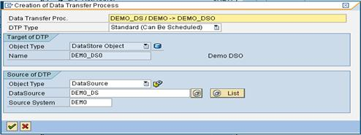

**Step 4) Create Infopackage and Schedule dataload to the DataSource(PSA).**

1. Enter RSA1 in command prompt
2. Hit Enter
3. Navigate to Modeling tab->DataSources.
4. Right click on the DataSource -> Create InfoPackage.

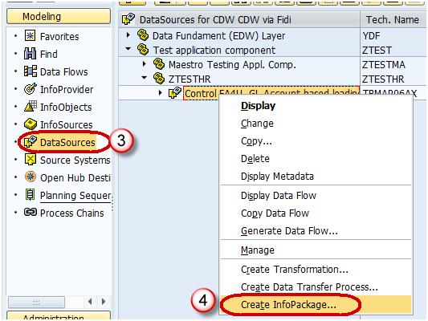

1. Enter the InfoPackage Description
2. Click Save.

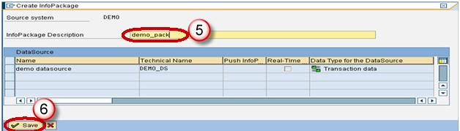

1. Click on Schedule tab.
2. Click Start button to start the load from the flat file to the Data Source.

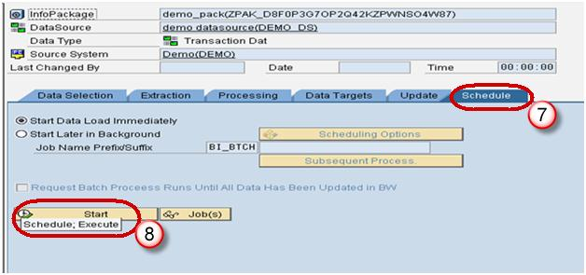

**Step 5) Load data to the DSO.**

1. Click Execute tab in the DTP.
2. Click the Execute Button to start data load from the DataSource(PSA) to the DSO.

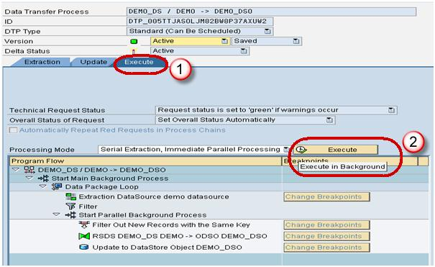

**How To Load Transaction Data From Flat File**

**Details**

Last Updated: Sunday, 04 September 2016 16:00

We will learn how to load transactional data from a Flat File with the help of a scenario.

Scenario: Load data to the DSO named “DEMO_DSO”. The DSO has the following fields.

**Key Fields:**

ZCUST - Customer

ZMAT – Material

**Data Fields:**

ZPRICE – Material Price

ZQTY - Quantity

[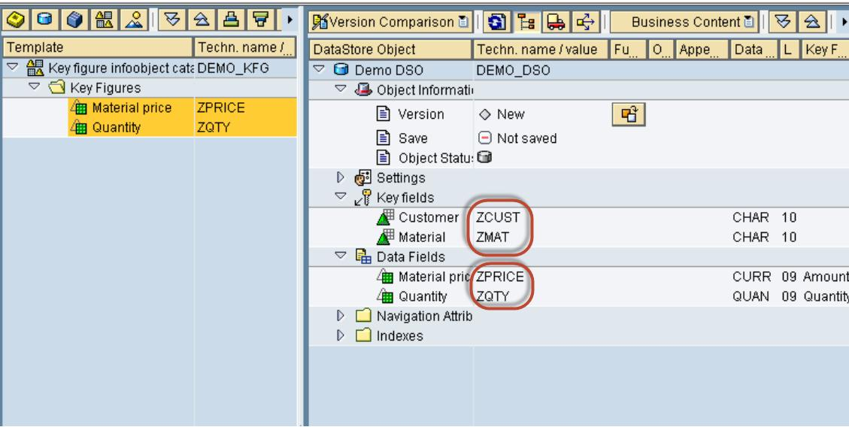](http://cdn.guru99.com/images/sap/SAP_BI/sap_bi_15_1.jpg)

Lets look into the Steps to Load data to DSO from Flat file

**Step 1) Create source system for flat file.**

1. Go to transaction code RSA1
2. Click the OK button.

[](http://cdn.guru99.com/images/sap/SAP_BI/sap_bi_15_2.jpg)

In the next screen,

1. Navigate to Modeling tab->Source Systems.
2. Right click on the folder named FILE and choose “Create” from the context menu.

[](http://cdn.guru99.com/images/sap/SAP_BI/sap_bi_15_3.jpg)

In the next screen,

1. Enter the Logical System Name.
2. Enter the Description.Click Continue Button.

[](http://cdn.guru99.com/images/sap/SAP_BI/sap_bi_15_4.jpg)

**Step 2) Create Application component.**

1. Go to transaction code RSA1
2. Click the OK button.

[](http://cdn.guru99.com/images/sap/SAP_BI/sap_bi_15_5.jpg)

1. Navigate to Modeling tab->Data Sources.
2. Choose the Source System.

[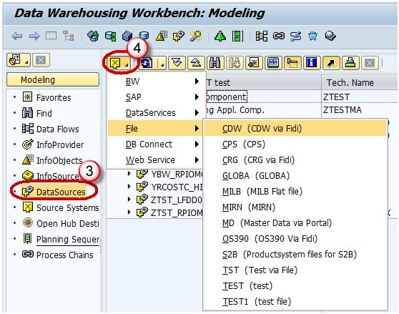](http://cdn.guru99.com/images/sap/SAP_BI/sap_bi_15_6.jpg)

1. Right click -> Create Application Component.

[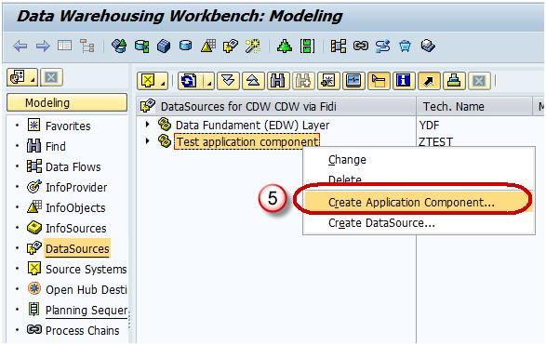](http://cdn.guru99.com/images/sap/SAP_BI/sap_bi_15_7.jpg)

1. Enter the Technical Name.
2. Enter the Description.
3. Click Continue.

[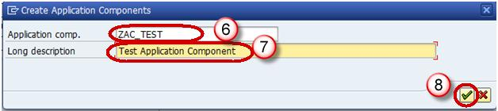](http://cdn.guru99.com/images/sap/SAP_BI/sap_bi_15_8.jpg)

**Step 3) Create Data Source.**

1. Go to transaction code RSA1
2. Click the OK button.

[](http://cdn.guru99.com/images/sap/SAP_BI/sap_bi_15_9.jpg)

1. Navigate to Modeling tab->Data Sources.
2. Right click -> Create Data Source.

[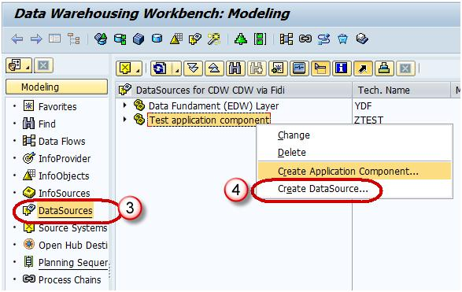](http://cdn.guru99.com/images/sap/SAP_BI/sap_bi_15_10.jpg)

1. Enter Technical Name.
2. Choose the DataType DataSource.
3. Click Continue.

[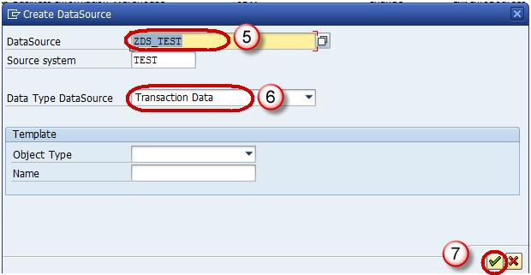](http://cdn.guru99.com/images/sap/SAP_BI/sap_bi_15_11.jpg)

1. Enter the Fields shown below. This Structure should be the same as the DSO to which transaction data is to be loaded.

[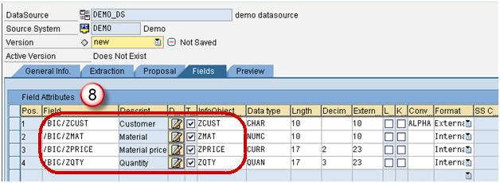](http://cdn.guru99.com/images/sap/SAP_BI/sap_bi_15_12.jpg)

1. In the Extraction tab, choose the Adapter as “Load Text-Type File from Local Workstation”.
2. Choose the file path where the flat file to be loaded is placed in the system and activate data source.

[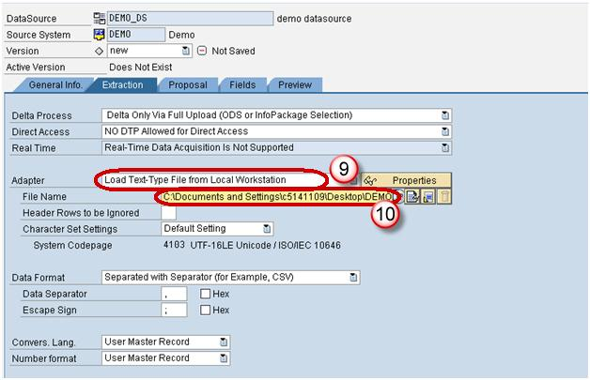](http://cdn.guru99.com/images/sap/SAP_BI/sap_bi_15_13.jpg)

**Step 4) Create transformation between Data Source(Source) and DSO(Target).**

1. Go to transaction code RSA1.
2. Click the OK button.

[](http://cdn.guru99.com/images/sap/SAP_BI/sap_bi_15_14.jpg)

1. Navigate to Modeling tab->InfoProvider.
2. Create Transformation.

[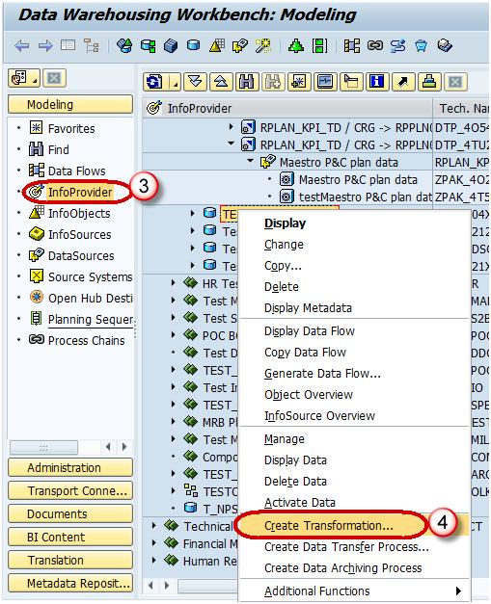](http://cdn.guru99.com/images/sap/SAP_BI/sap_bi_15_15.jpg)

1. Enter Target Object Type.
2. Enter Target Object Name.
3. Enter Source Object Type.
4. Enter Source Object Name.
5. Enter the Source System.
6. Click Continue.

[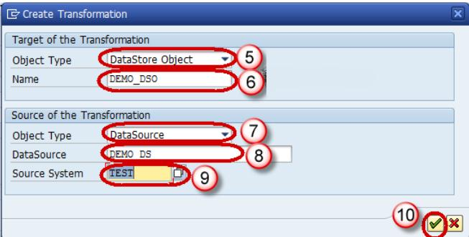](http://cdn.guru99.com/images/sap/SAP_BI/sap_bi_15_16.jpg)

Below screen shows the transformation created with automatic mapping of the Source fields to the Target fields.

[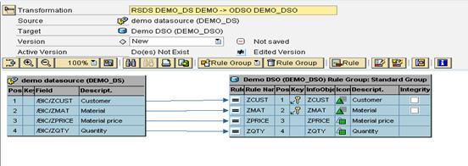](http://cdn.guru99.com/images/sap/SAP_BI/sap_bi_15_17.jpg)

**Step 5) Create Data Transfer Process.**

Right-Click on DTP folder and choose the option “Create Data Transfer Process” from the context menu.

[](http://cdn.guru99.com/images/sap/SAP_BI/sap_bi_15_18.jpg)

Below screen shows the DTP created.

[](http://cdn.guru99.com/images/sap/SAP_BI/sap_bi_15_19.jpg)

**Step 6) Create Infopackage and Schedule dataload to the DataSource(PSA).**

1. Go to transaction code RSA1.
2. Click the OK button.

[](http://cdn.guru99.com/images/sap/SAP_BI/sap_bi_15_20.jpg)

1. Navigate to Modeling tab->DataSources.
2. Right click on the DataSource -> Create InfoPackage.

[](http://cdn.guru99.com/images/sap/SAP_BI/sap_bi_15_21.jpg)

1. Enter the InfoPackage Description.
2. Click Save.

[](http://cdn.guru99.com/images/sap/SAP_BI/sap_bi_15_22.jpg)

1. Click on Schedule tab.
2. Click Start button to start the load from the flat file to the Data Source.

[](http://cdn.guru99.com/images/sap/SAP_BI/sap_bi_15_23.jpg)

**Step 7) Load data to the DSO.**

1. Click Execute tab in the DTP.
2. Click the Execute Button to start data load from the DataSource(PSA) to the DSO.

[](http://cdn.guru99.com/images/sap/SAP_BI/sap_bi_15_24.jpg)

**How To Load Master Data From ECC?**

**Details**

Last Updated: Sunday, 04 September 2016 16:00

**Step 1) Creating a Generic Data Source for Text InfoObject**

Right click on the BI Source System -> Customizing Extractors.

[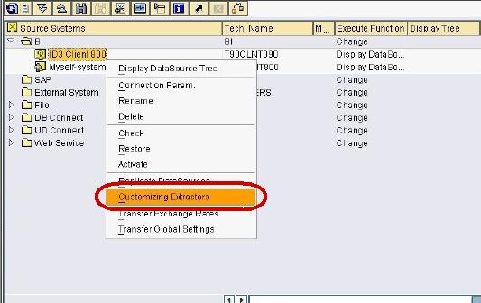](http://cdn.guru99.com/images/sap/SAP_BI/sap_bi_16_1.jpg)

In next screen,  click on Maintain Generic DataSources.

[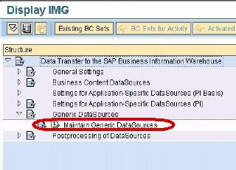](http://cdn.guru99.com/images/sap/SAP_BI/sap_bi_16_2.jpg)

In next screen,

1. Type a Technical name for the Text.
2. Click Create Button.

[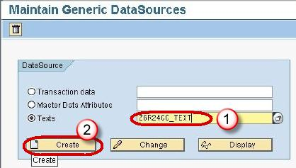](http://cdn.guru99.com/images/sap/SAP_BI/sap_bi_16_3.jpg)

In next screen,

1. Enter the Short, Medium and Long Description.
2. Enter the View/Table name.

[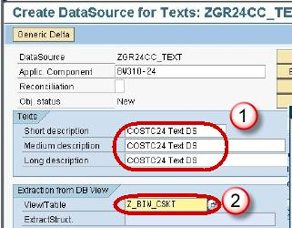](http://cdn.guru99.com/images/sap/SAP_BI/sap_bi_16_4.jpg)

Press the Enter button. The below screen is displayed.

[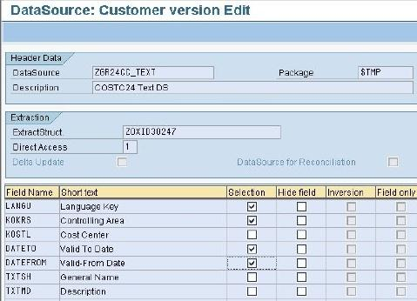](http://cdn.guru99.com/images/sap/SAP_BI/sap_bi_16_5.jpg)

Now,

1. Go to transaction code RSA1
2. Click the OK button.

[](http://cdn.guru99.com/images/sap/SAP_BI/sap_bi_16_6.jpg)

In next screen,

1. Go to the Datasource tab
2. Click Find
3. Type the datasource technical name.
4. Click Search button.

[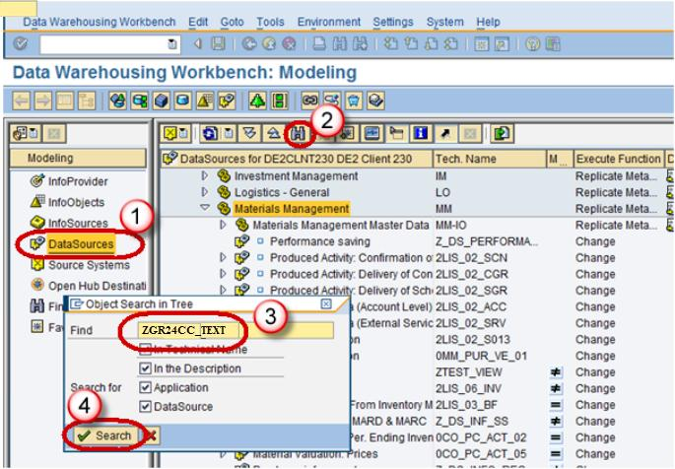](http://cdn.guru99.com/images/sap/SAP_BI/sap_bi_16_7.jpg)

Next, from the datasource **ZGR24CC_TEXT**, right click Replicate Metadata as shown below. Activate the DataSource.

[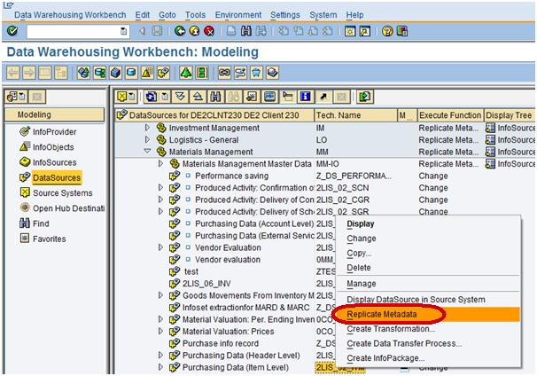](http://cdn.guru99.com/images/sap/SAP_BI/sap_bi_16_8.jpg)

**Step 2) Create transformation between Data Source(Source) and InfoObject Text(Target).**

1. Go to transaction code RSA1
2. Click the OK button.

[](http://cdn.guru99.com/images/sap/SAP_BI/sap_bi_16_9.jpg)

In next screen,  right click on the DataSource -> Create Transformation

[](http://cdn.guru99.com/images/sap/SAP_BI/sap_bi_16_10.jpg)

In next screen,

1. Enter Target Object Type.
2. Enter Target Object Name.
3. Enter the SubType. Choose Text.
4. Click Continue.

[](http://cdn.guru99.com/images/sap/SAP_BI/sap_bi_16_11.jpg)

The transformation would be created with automatic mapping of the Source fields to the Target fields.

**Step 3) Create Infopackage and Schedule Dataload to the DataSource(PSA).**

1. Go to transaction code RSA1
2. Click the OK button.

[](http://cdn.guru99.com/images/sap/SAP_BI/sap_bi_16_12.jpg)

1. Navigate to Modeling tab->DataSources.
2. Right click on the DataSource -> Create InfoPackage.

[](http://cdn.guru99.com/images/sap/SAP_BI/sap_bi_16_13.jpg)

1. Enter the InfoPackage Description
2. Click Save.

[](http://cdn.guru99.com/images/sap/SAP_BI/sap_bi_16_14.jpg)

1. Click on Schedule tab.
2. Click Start button to start the load from the flat file to the Data Source.

[](http://cdn.guru99.com/images/sap/SAP_BI/sap_bi_16_15.jpg)

**Step 4) Create Data Transfer Process.**

Right-Click on DTP folder and choose the option “Create Data Transfer Process” from the context menu.

[](http://cdn.guru99.com/images/sap/SAP_BI/sap_bi_16_16.jpg)

The below shows the DTP created.

[](http://cdn.guru99.com/images/sap/SAP_BI/sap_bi_16_17.jpg)

**Step 5) Load Data to the InfoObject Text.**

1. Click Execute tab in the DTP.
2. Click the Execute Button to start data load from the DataSource(PSA) to the InfoObject Text.

[](http://cdn.guru99.com/images/sap/SAP_BI/sap_bi_16_18.jpg)

**How To Load Transaction Data From ECC?**

**Details**

Last Updated: Sunday, 04 September 2016 16:00

Following are the steps to perform the data extraction from ECC into BW systems. We will take Logistics (Purchasing application module) in our example.

**Step 1)**

Login into  ERP system

1. Input the T code- RSA5.
2. Click Continue button.

[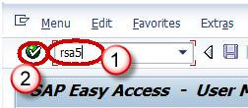](http://cdn.guru99.com/images/sap/SAP_BI/sap_bi_17_1.jpg)

**Step 2)**

Click on the folder SAP R/3 as shown below screenshot

[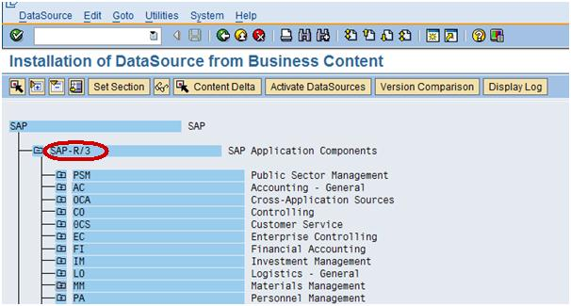](http://cdn.guru99.com/images/sap/SAP_BI/sap_bi_17_2.jpg)

**Step 3)**

Go to the Folder MM (Materials Management)—MM-IO as shown below in screenshot in Box.

[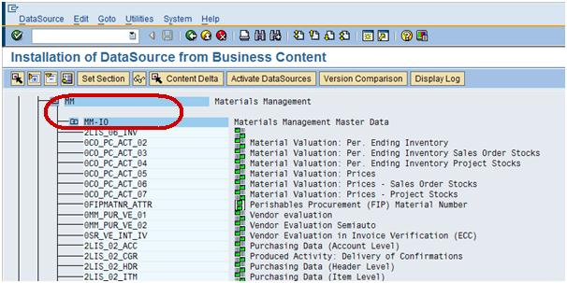](http://cdn.guru99.com/images/sap/SAP_BI/sap_bi_17_3.jpg)

**Step 4)**

Choose the datasource 2LIS_02_ITM, which is purchasing data at Item level.

[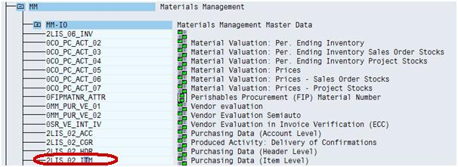](http://cdn.guru99.com/images/sap/SAP_BI/sap_bi_17_4.jpg)

**Step 5)**

Choose the datasource 2LIS_02_ITM and go to the Datasource tab and click Change the datasource as shown in screenshot.

[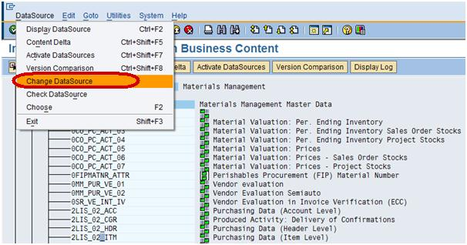](http://cdn.guru99.com/images/sap/SAP_BI/sap_bi_17_5.jpg)

**Note:** This step is used when we need to add additional fields, to push into BW. Similarly, we can do the same steps (Step1-5) for of fields which we don’t wish to populate in BW.

After choosing the Change datasource tab, you can see all the fields associated with this datasource as shown below.

[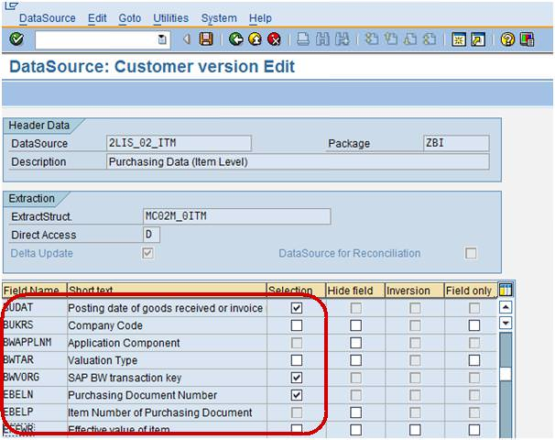](http://cdn.guru99.com/images/sap/SAP_BI/sap_bi_17_6.jpg)

**Step 6)**

Now, as per the above screenshot the Field EFFWR –Effective value item is unchecked in selection field which means that it is not available in BW. To populate the Field EFFWR in BW, we will have to check mark in selection field as shown below.

[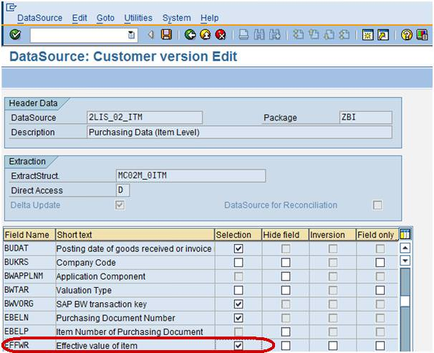](http://cdn.guru99.com/images/sap/SAP_BI/sap_bi_17_7.jpg)

**Step 7)**

After checking the field EFFWR in selection save the datasource as shown below.

[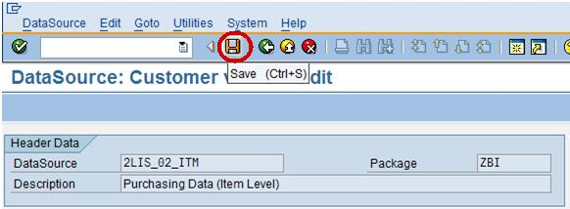](http://cdn.guru99.com/images/sap/SAP_BI/sap_bi_17_8.jpg)

**Step 8)**

Activate the datasource as shown below.

[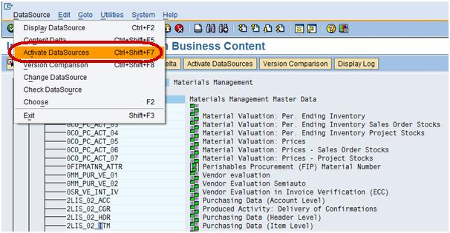](http://cdn.guru99.com/images/sap/SAP_BI/sap_bi_17_9.jpg)

Now we are ready to push the changed datasource 2LIS_02_ITM after selecting the Field EFFWR into BW.

**Step 9)**

1. Log into BW system, go to the Datasource tab
2. Click Find to search.
3. Type the datasource technical name.
4. Click Search button.

[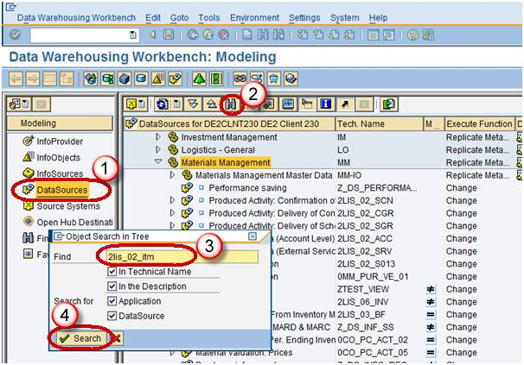](http://cdn.guru99.com/images/sap/SAP_BI/sap_bi_17_10.jpg)

**Step 10)**

From the datasource 2LIS_02_ITM, right click Replicate Metadata as shown below.

[](http://cdn.guru99.com/images/sap/SAP_BI/sap_bi_17_11.jpg)

After sucessfull replication of datasource, the Filed EFFWR will be available in BW

[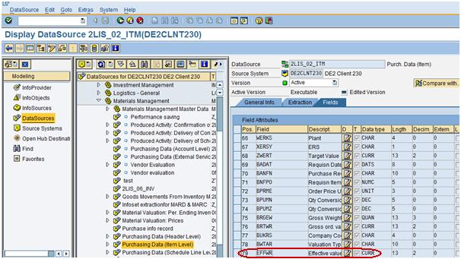](http://cdn.guru99.com/images/sap/SAP_BI/sap_bi_17_12.jpg)

**Step 11)**

Load the data from ECC into BW to populate the filed EFFWR with some data.

1. Go to transaction code RSA1
2. Click the OK button.

[](http://cdn.guru99.com/images/sap/SAP_BI/sap_bi_17_13.jpg)

1. Navigate to Modeling tab->DataSources.
2. Right Click on DataSource -> Create Infopackage.

[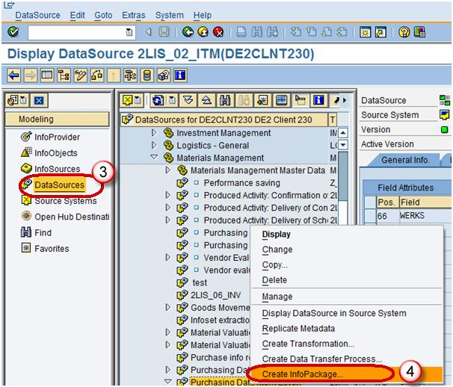](http://cdn.guru99.com/images/sap/SAP_BI/sap_bi_17_14.jpg)

This Infopackage is used to load the data from ECC into BW system at PSA level which is intermediate level.

1. Enter the InfoPackage Description.
2. Click Save.

[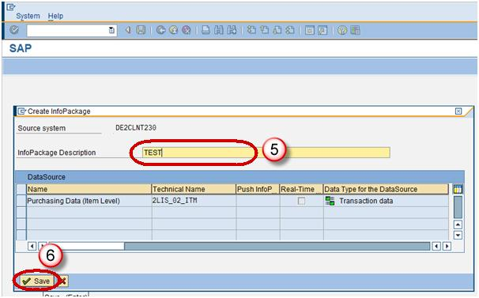](http://cdn.guru99.com/images/sap/SAP_BI/sap_bi_17_15.jpg)

1. In order to trigger the data load from ECC into BW, go to the Infopackage, Click on Schedule tab.
2. Click Start button to start the load from the flat file to the Data Source.

[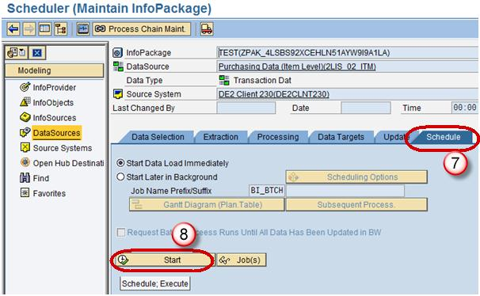](http://cdn.guru99.com/images/sap/SAP_BI/sap_bi_17_16.jpg)

**All About Classical & Extended Star Schema**

**Details**

Last Updated: Sunday, 04 September 2016 16:00

**What is Schema ?**

In database management system (DBMS), the schema represents relational database. It defines the tables, the fields in each table and the relationship between fields and tables. In other words schema is a collection of database objects, including tables, views, indexes and synonyms.  Schemas are generally stored in a data dictionary.

**What is Classical Star Schema?**

A classical star schema is a multidimensional data model.It is based on a central **fact table** surrounded by several dimension tables in the shape of a star (hence the name).

An InfoCube consists of several Info-Objects (Characteristics and Key figures) and is structured according to the star schema. This means that there is a large fact table with key figures for the InfoCube, as well as many dimension table surround it structure which appears like star.

The benefits of star schema are slicing down, easy understanding of data and performance increase.

[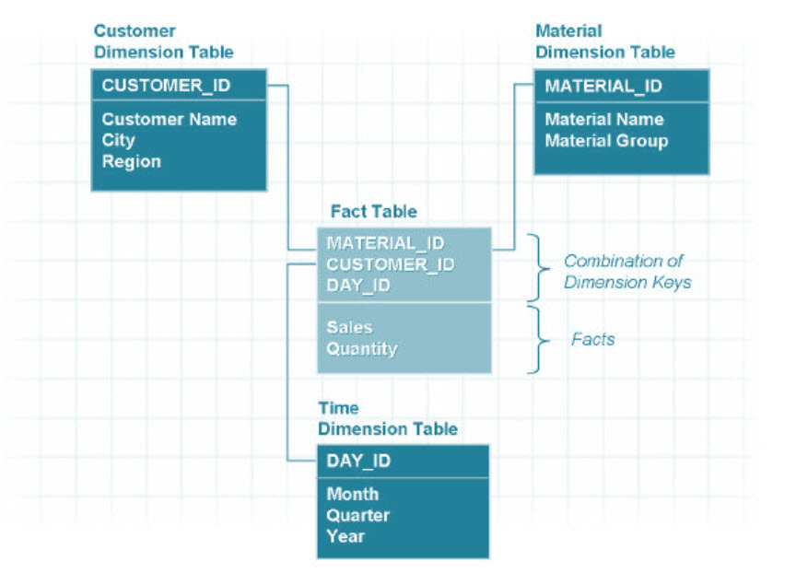](http://cdn.guru99.com/images/sap/SAP_BI/sap_bi_18_1.jpg)

**What is Extended Star Schema?**

In extended star schema, “fact table” and “master data table”  is  connected  through SID (Surrogate ID)  table.  In extended star schema , fact table and dimension table will be inside the cube. It  has analyzing  capacity of  16*248  (SID Table). Fact table is small and dimension table is huge contrary to Star Schema model.  Under the extended star schema model, the dimension table do not contain master data

[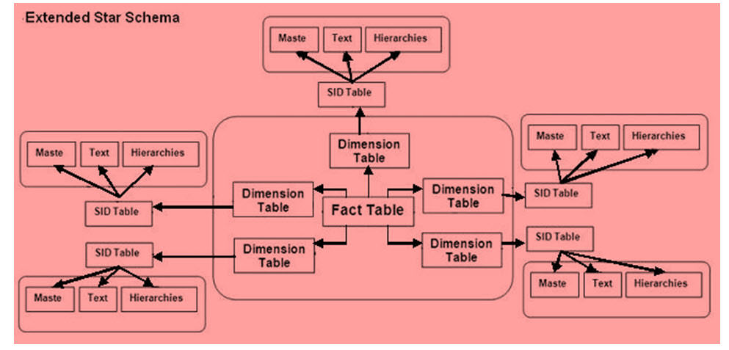](http://cdn.guru99.com/images/sap/SAP_BI/sap_bi_18_2.jpg)

Following are the different components of an Extended Star Schema.

1. Attribute table holds the attribute of master data.
2. SID table creates the unique SID for (Surrogate Id) every master data records.
3. Dimension table creates the DimId for every unique combination of SID(Max 248 SID(characters) can accommodate in DIM table).
4. Text table hold description of master data.
5. Fact table contains unique combination of DIM ID and key figures (Max 233 key figures (measurable quantity) can accommodate in fact table).

[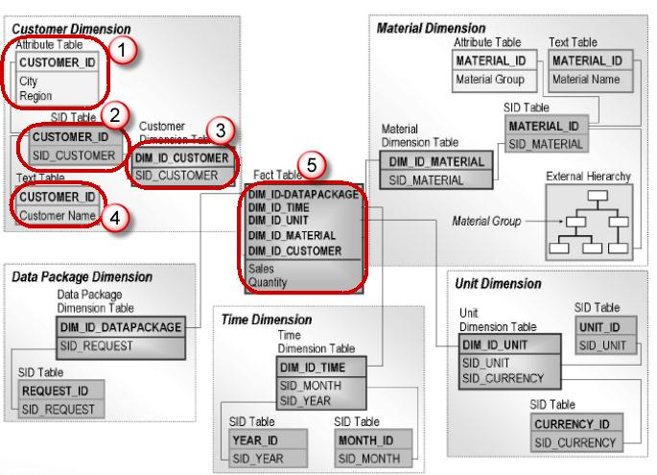](http://cdn.guru99.com/images/sap/SAP_BI/sap_bi_18_3.jpg)

Below is an example of how a fact table of an Infocube looks like.

[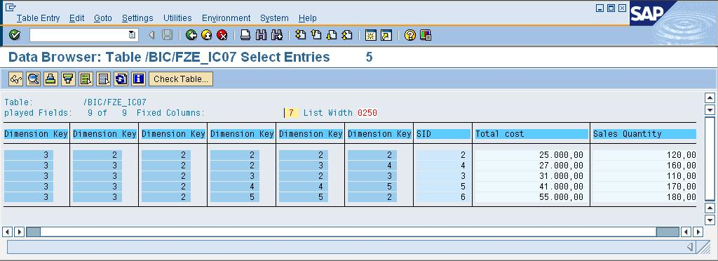](http://cdn.guru99.com/images/sap/SAP_BI/sap_bi_18_4.jpg)

Below are the Dimension and SID tables.

[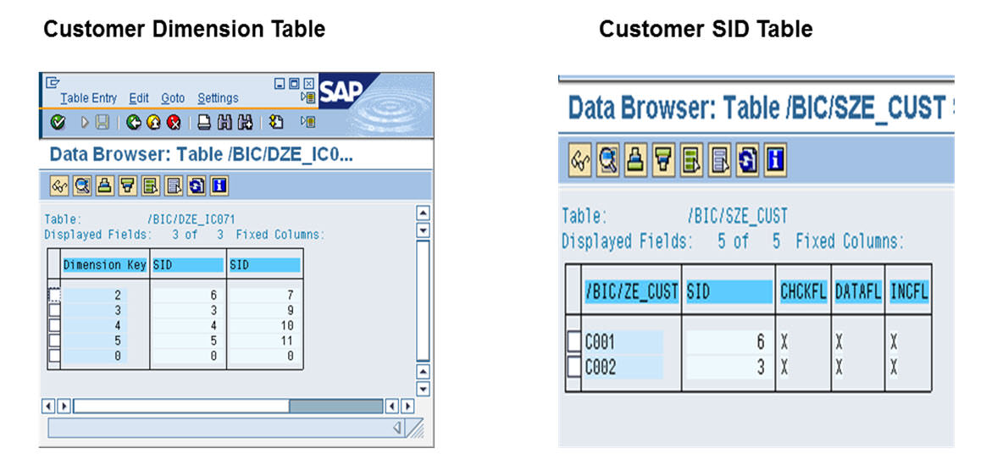](http://cdn.guru99.com/images/sap/SAP_BI/sap_bi_18_5.jpg)

Below shown are the Info object master data and text table.

[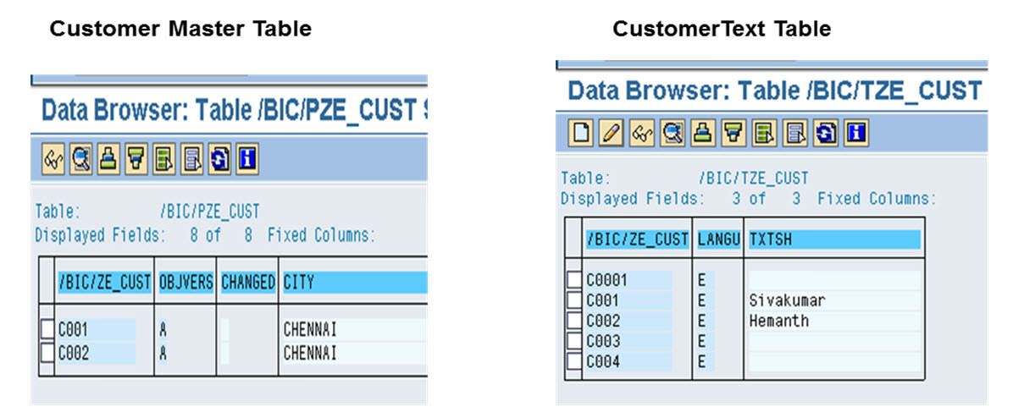](http://cdn.guru99.com/images/sap/SAP_BI/sap_bi_18_6.jpg)

**Infocube : Sample Extended Star Schema:**

The below is an example of Infocube showing the Extended Star Schema.

**Steps explaining the Extended Star Schema of an Infocube:**

1. The Fact table of the InfoCube has a value 3.
2. The value of the fact table (i.e “3”) is mapped in the Dimension table.
3. The Dimension ID “3” has an SID mapped in the SID table.
4. The SID value is mapped with the Text and Master data table.

[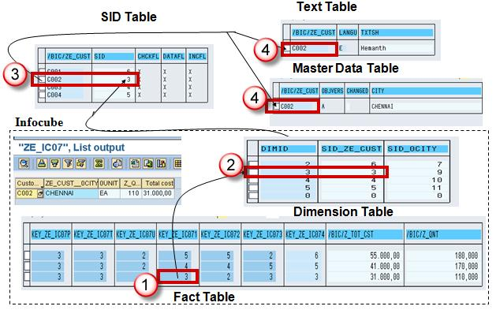](http://cdn.guru99.com/images/sap/SAP_BI/sap_bi_18_7.jpg)

**All About Process Chains in SAP BI/BW**

**Details**

Last Updated: Sunday, 04 September 2016 16:00

* A process chain is a sequence of processes that wait in the background for an event.
* Some of these processes trigger a separate event that can start other processes in turn.
* It provides various connectors that allow alternative and parallel execution of process.
* For example, a retail store receives a customer order, this will trigger a sequence of events like checking material in stockàordering the product from Warehouseàorder to manufacture the product and so on.
* Process chains provide graphical scheduling & monitoring features to help in automation, visualization & monitoring of tasks / processes.
* Process chains are integrated into portal based BI administration cockpit.
* Process Chains can be thought of as flowcharts which are scheduled to wait in background & triggered for an event by another process.

[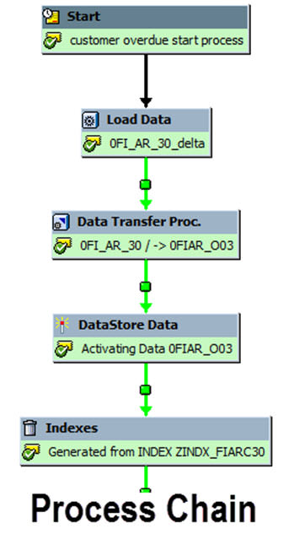](http://cdn.guru99.com/images/sap/SAP_BI/sap_bi_19_1.jpg)

Process Chain involves three main steps

1. Start Process: It describes when the process will start (immediately, scheduled job, metaprocess, API)
2. Connector: It is a linking process, and can choose options of starting next process
3. Variant: The object on which we are supposed to execute the process is called as Variant. It is a set of parameters passed to the process like name of the InfoPackage or Info-Objects

In this tutorial you will learn –

Steps to create a process chain.

Steps to check consistency of process chain.

Steps to activate a process chain.

Steps to assign Process Chain to application component.

Steps to activate a Process Chain.

How to Monitor Process Chains.

**Steps To Create a Process Chain**

RSPC is the whole and sole transaction used for Process Chain Maintenance. In this screen, existing process chains are sorted by “ApplicationComponents”.

 There are two views available:

1. Check View
2. Planning View.

The default mode is Planning View.

**Step 1)**

Creating a Process Chain:

Click the “Create” icon.

[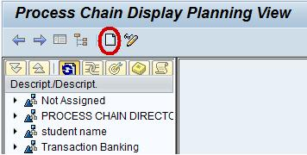](http://cdn.guru99.com/images/sap/SAP_BI/sap_bi_19_2.jpg)

**Step 2)**

1. Enter the Technical name of the Process Chain.
2. Enter a meaningful description for the Process Chain.

[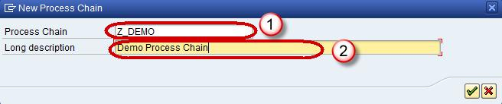](http://cdn.guru99.com/images/sap/SAP_BI/sap_bi_19_3.jpg)

Click Check Mark

**Step 3)**

A new window pops-up. Click on “New” icon to create a new “Start Process”.

[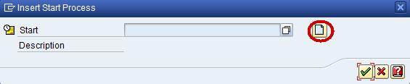](http://cdn.guru99.com/images/sap/SAP_BI/sap_bi_19_4.jpg)

**Step 4)**

1. Enter the Technical name of the Start Process.
2. Enter a meaningful description for the Start Process and click the Enter button.

[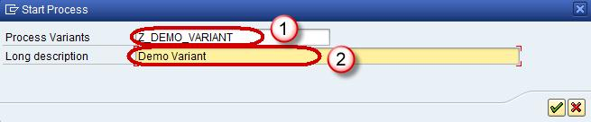](http://cdn.guru99.com/images/sap/SAP_BI/sap_bi_19_5.jpg)

**Step 5)**

The subsequent screen is used to assign time-based or event based trigger for the process chain.

1. Click on the option “Direct Schedule” to schedule the process chain for a specific time.
2. Click on the button “Change Selections” to enter the details for Scheduling the Process chain for execution.

[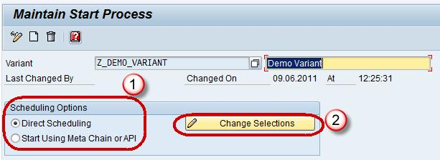](http://cdn.guru99.com/images/sap/SAP_BI/sap_bi_19_6.jpg)

**Step 6)**

Steps for Scheduling a Process Chain:

1. Click on the “Date/Time” button. Specify the Scheduled Start date/time,end date/time.
2. To set frequency, click on the check box “Periodic Job”.
3. Click the button “PeriodValues”.
4. In next screen, select required frequency (Hourly/Daily/Weekly/Monthly/Other Period). Click on Save icons and back button to go back to previous RSPC screen.

[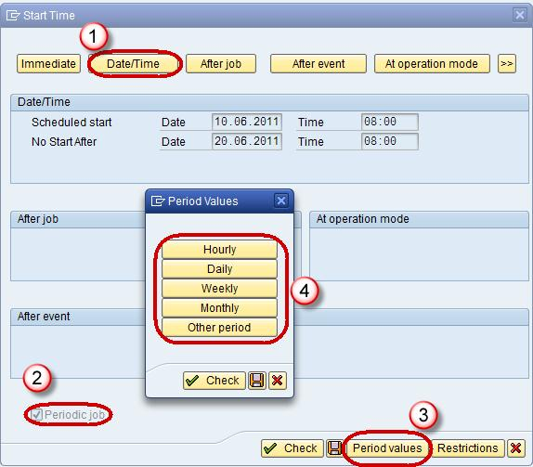](http://cdn.guru99.com/images/sap/SAP_BI/sap_bi_19_7.jpg)

Click save

**Step 7)**

Add Info Package:

Click on icon for “Process Types” to proceed.

[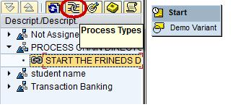](http://cdn.guru99.com/images/sap/SAP_BI/sap_bi_19_8.jpg)

**Step 8)**

As discussed earlier, data load can be triggered via an InfoPackage or a DTP.

1. If the dataload is to be done via an InfoPackage, use the Process type “Execute InfoPackage”
2. If the dataload is to be done via a DTP, use the Process type “Data Transfer Process”

**[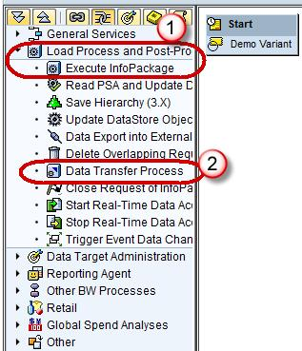](http://cdn.guru99.com/images/sap/SAP_BI/sap_bi_19_9.jpg)**

**Step 9)**

A new pop-up window appears. Here you can choose the required InfoPackage.

**[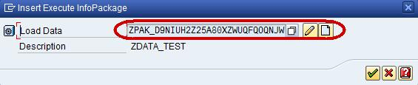](http://cdn.guru99.com/images/sap/SAP_BI/sap_bi_19_10.jpg)**

**Step 10)**

Connect both the Start Variant and the InfoPackage:

There are 2 ways to do this – Right click on first step. Click on “Connect With” ->“Load Data”

Another way is to select the “Start Variant” and keep the left mouse button pressed. Then move mouse button to the target step. An arrow should follow your movement. Stop pressing the mouse button and new connection is created. From the start process to every second step there is a black line.

[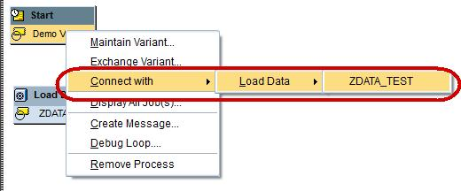](http://cdn.guru99.com/images/sap/SAP_BI/sap_bi_19_11.jpg)

The Process chain appears as below after a Connection between the Start variant and Infopackage is created.

[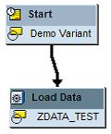](http://cdn.guru99.com/images/sap/SAP_BI/sap_bi_19_20.jpg)

For any subsequent step, we can choose if the successor step shall be executed only if the predecessor.

* Was successful: typically used in normal processing
* Ended with errors: Typically used to send failure messages
* Execute irrespective of success or failure of previous step

[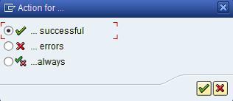](http://cdn.guru99.com/images/sap/SAP_BI/sap_bi_19_12.jpg)

**Steps To Check Consistency of Process Chain**

1. Select the menu “Goto”
2. Choose “Checking view”.

[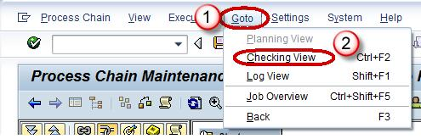](http://cdn.guru99.com/images/sap/SAP_BI/sap_bi_19_13.jpg)

SAP will verify if all steps are connected and have at least one predecessor. Logical errors are not detected. If we get warnings or “Chain is OK”message, we can activate it. If the check identifies some errors , we have to remove the errors first.

[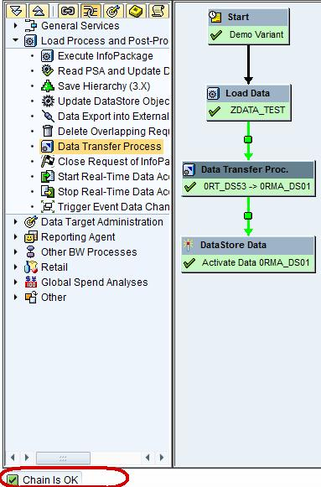](http://cdn.guru99.com/images/sap/SAP_BI/sap_bi_19_14.jpg)

**Steps To Activate a Process Chain**

1. Click on the menu “Process Chain”
2. Select “Activate”.
3. Or select the “Activate” button

**[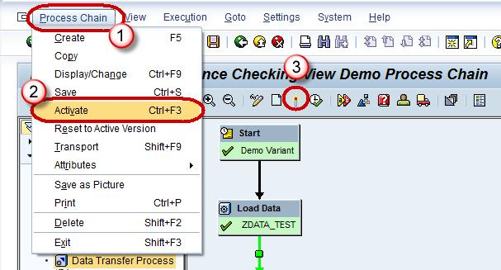](http://cdn.guru99.com/images/sap/SAP_BI/sap_bi_19_15.jpg)**

**Steps To Assign Process Chain To Application Component**

By default, the Process Chain is created under application component “Not Assigned”.

1. Choose “ApplicationComponent” button
2. Select the required component and Re-Activate the chain.

[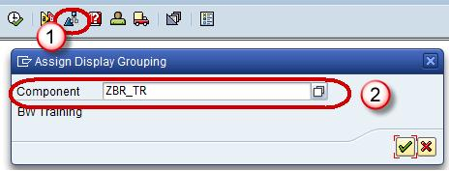](http://cdn.guru99.com/images/sap/SAP_BI/sap_bi_19_16.jpg)

**Steps To Activate a Process Chain**

1. Click on the menu “Execution”.
2. Choose “Schedule”.

[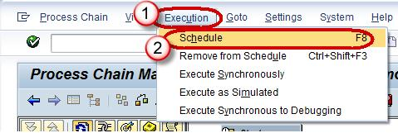](http://cdn.guru99.com/images/sap/SAP_BI/sap_bi_19_17.jpg)

Alternatively press the button “Schedule”.

The chain will be scheduled as background job and can be viewed in SM37 transaction code. You will find a job named “BI_PROCESS_TRIGGER”. All the Process chains are scheduled with same job name.

[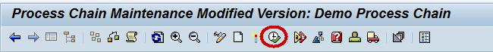](http://cdn.guru99.com/images/sap/SAP_BI/sap_bi_19_18.jpg)

**How to Monitor Process Chains**

1. There are a number of work environments available for monitoring process chain runs:
2. Navigate to Administration tab from DatawarehouseWorkBench(RSA1)
3. BI Monitor in the Computing Center Management System (CCMS)
4. Monitoring of Daily Process Chains (Transaction RSPCM)
5. Log view for runs of a process chain in process chain maintenance (transaction RSPC)

[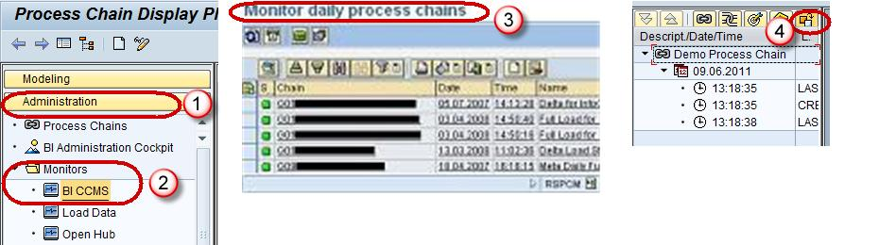](http://cdn.guru99.com/images/sap/SAP_BI/sap_bi_19_19.jpg)

**Installing BW Standard Content**

**Details**

Last Updated: Sunday, 04 September 2016 16:00

**BI Content:**

BI Content provides selected roles within a company with the information that they need to carry out their tasks. SAP NetWeaver Business Warehouse delivers pre-configured authorization objects under the collective term BI content. To understand this we take an example of a sales manager, who wants all the information like sales, market share, product quality, sales and service cost etc… to enable him to make effective decision. A BI content role will bring all this data together in the form of workbooks and queries carrying exactly the information the sales manager needs. No sensitive & confidential information from the HR department are shown to him

[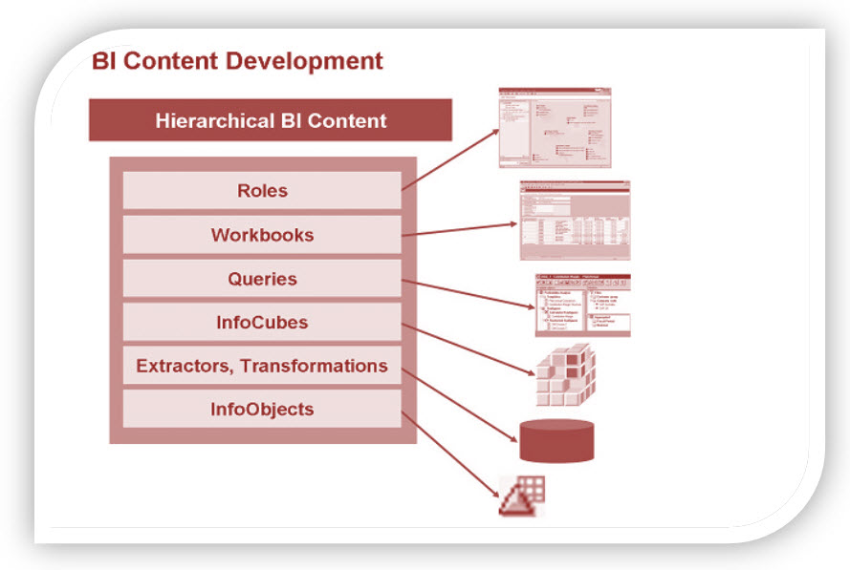](http://cdn.guru99.com/images/sap/SAP_BI/sap_bi_20_1.jpg)

**Benefits of BI Content:**

Below mentioned are the benefits of using BI Content.

* Be used in particular industries without being modified
* Be modified, meaning you can customize  it to any degree of detail
* Serve as a template or an example for customer-defined Business Content
* Immediate access to interpreted information.
* Ready-to-go reports, data models, extractors, transformations
* Significant cut down of implementation time and costs
* Consistency of operational processes with management processes
* Easily extensible
* Automatic improvements to the information model
* Data consistency and integrity
* Rich set of standard key performance indicators

**BI Content Objects:**

Business Content includes:

* SAP extractor programs
* Data Sources
* Process Chains
* InfoObjects
* InfoSources
* Data targets (Info Cubes and DSO objects)
* Variables
* Queries
* Workbooks
* Transformations and Update Rules
* Web templates
* oles

**Activation of BI Content:**

Steps to view and activate objects available via BI Content:

**Step 1)**

1. Go to Transaction Code RSA1.
2. Click the “Ok” button.

[](http://cdn.guru99.com/images/sap/SAP_BI/sap_bi_20_2.jpg)

**Step 2)**

1. Browse to the tab “BI Content”.
2. Click on “Object Types.”

[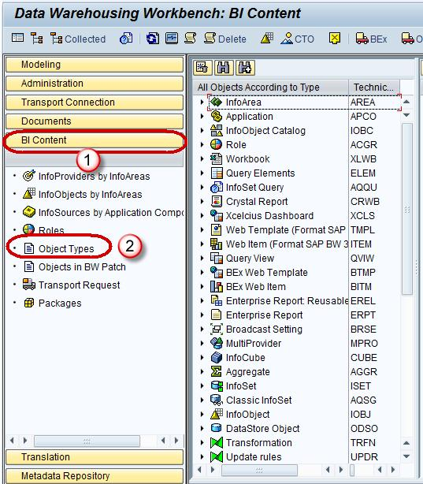](http://cdn.guru99.com/images/sap/SAP_BI/sap_bi_20_3.jpg)

**Step 3)**

You can browse the BI Content using different views. In attached screenshot, the content is grouped by “Object Type”.

1. Click on “Select Objects” for required Object Type. Each object type is meant for a different role in an organiztion
2. In the subsequent screen, select the required objects.
3. Click on“Transfer Selection”.

[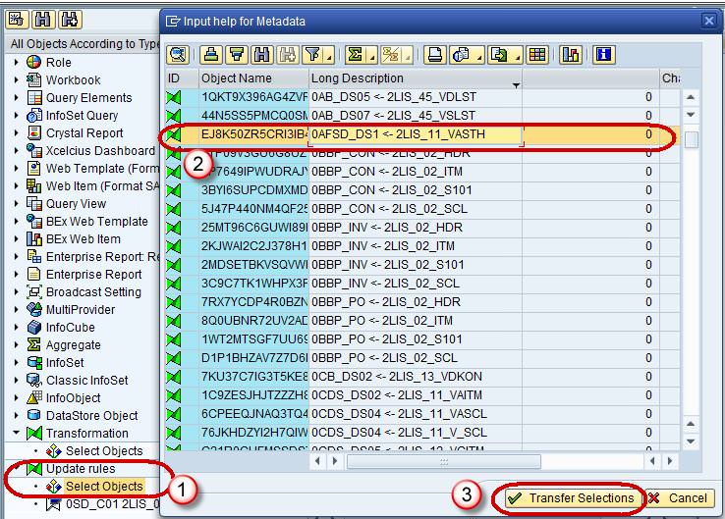](http://cdn.guru99.com/images/sap/SAP_BI/sap_bi_20_4.jpg)

**Step 4)**

The selected objects and all the objects on which they are dependent are added hierarchically.

1. Select / deselect required objects
2. Click on “Install” Button
3. Click on Install from the drop-down.

[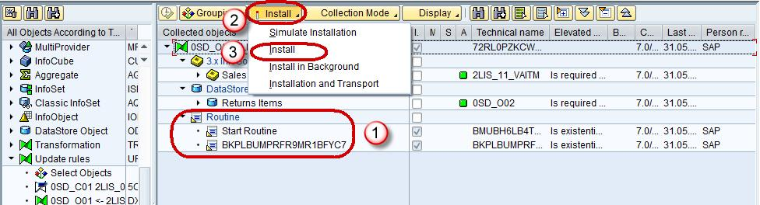](http://cdn.guru99.com/images/sap/SAP_BI/sap_bi_20_5.jpg)

**Introduction To BEX Query Designer and Query Elements**

**Details**

Last Updated: Sunday, 04 September 2016 16:00

1. The key to making informed decisions is having the right data in the right place at the right time.  Executives and line managers rely on business intelligence (BI) and reporting tools to deliver timely accurate and relevant data for both operational and strategic decisions.
2. The Business Explorer (BEx) is a component of SAP BI that provides flexible reporting and analysis tools that we can use for strategic analysis and supporting the decision-making process in an organization. These tools include query, reporting, and analysis functions.
3. SAP NetWeaver 7.0 provides the following tools:

* BEx Query Designer
* BEx Web Application Designer
* BEx Broadcaster
* BEx Analyzer

[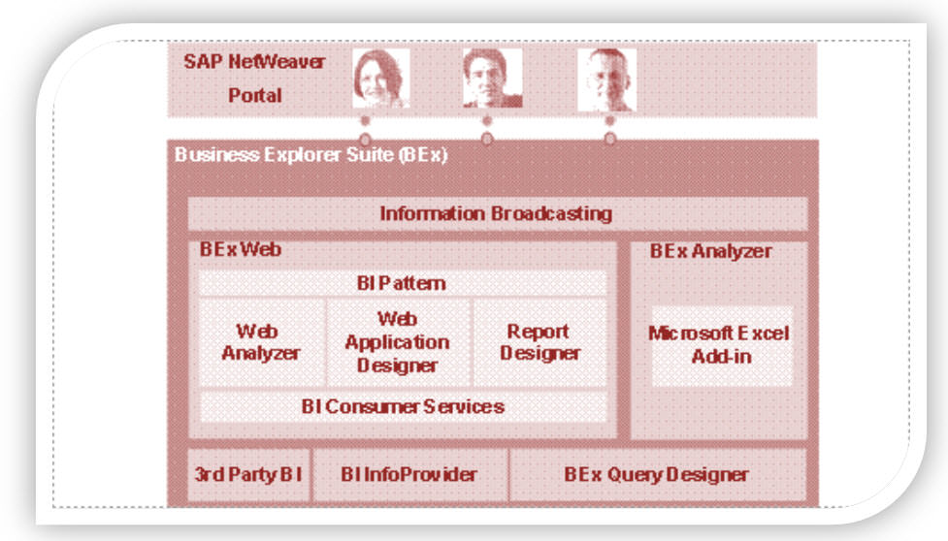](http://cdn.guru99.com/images/sap/SAP_BI/sap_bi_21_1.jpg)

1. The BEx tool can be used to display past and present data differing in the level of their details and from different perspective.
2. It can be used to create planning projections using  BI Integrated Planning.
3. The BEx Information Broadcasting can be used to distribute business intelligence content by e-mail, either as pre-calculated documents with historical data, or as links with live data.

**Query Designer:**

As the name suggests, it is used to define queries to retrieve data from SAP BW. Query Designer acts as the bridge between SAP BW InfoProviders and the reporting front-end tools (SAP BW / SAP BO).  It limits the field list displayed, which is based on their requirements. It also defines the default placement of these report objects within a report Query Designer and adds value by allowing users to define filters, selection screen variables (a.k.a. Prompts), Calculations, Unit Conversions, etc. that are not available in InfoProviders.

**Accessing Query Designer:**

To access BEx Query designer, follow the below steps.

**Step 1)**

1. Navigate to Start -> All Programs.
2. Under the folder “Business Explorer”, the “Query Designer” is available. Click on “Query Designer”.

[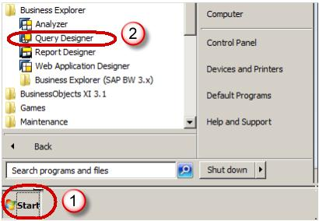](http://cdn.guru99.com/images/sap/SAP_BI/sap_bi_21_2.jpg)

**Step 2)**

1. Select required BW system
2. Click the Ok button

[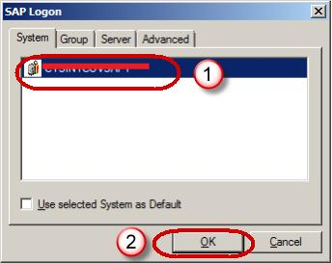](http://cdn.guru99.com/images/sap/SAP_BI/sap_bi_21_3.jpg)

1. Enter the Client
2. User Name
3. Password
4. Logon Language
5. Click the Ok Button

[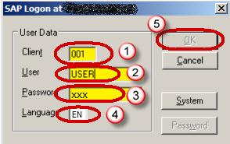](http://cdn.guru99.com/images/sap/SAP_BI/sap_bi_21_4.jpg)

**Query Panel:**

1. InfoProvider Details are available here.
2. Tabs to view various report components.
3. Properties Box which shows the properties of each component selected in the query.
4. System Messages such as any error or warning messages during the Query check is displayed here.
5. Shows the Where-Used List of any component selected within the query.

[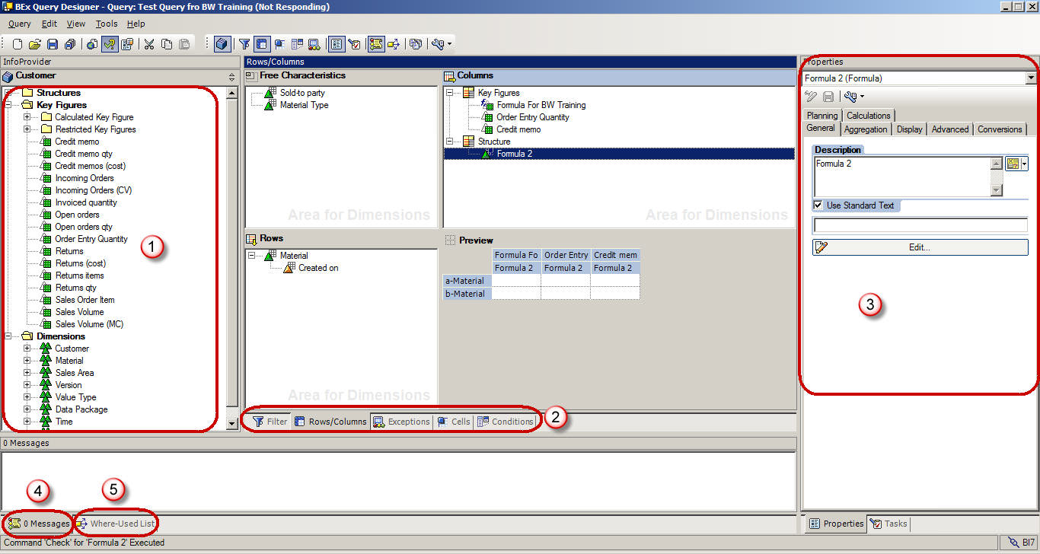](http://cdn.guru99.com/images/sap/SAP_BI/sap_bi_21_5.jpg)

**Query Panel – Standard Toolbar:**

The Standard tool bar in the Query Designer has the following buttons.

1. Create New Query
2. Open Query
3. Save Query
4. Save All
5. Publish on Web
6. Check Query
7. Query Properties
8. Cut
9. Copy
10. Paste
11. Toggle tabs for Filter and Rows/Columns
12. Cells
13. Conditions
14. Exceptions
15. Properties
16. Tasks
17. Messages
18. Where Used
19. Documents
20. Technical names

[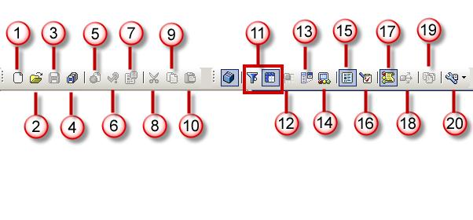](http://cdn.guru99.com/images/sap/SAP_BI/sap_bi_21_6.jpg)

**Query Elements:**

1. **Key Figures**: Key Figures represent the numerical data or the KPIs(Key Performance Indicator). They are further divided into Calculated Key Figures (CKF) and Restricted Key Figures (RKF).
2. **Characteristics :**A characteristic provides the criteria according to which objects are classified. e.g. Material,Period, Location, etc.
3. Navigational attributes appear as characteristics in Query designer.

[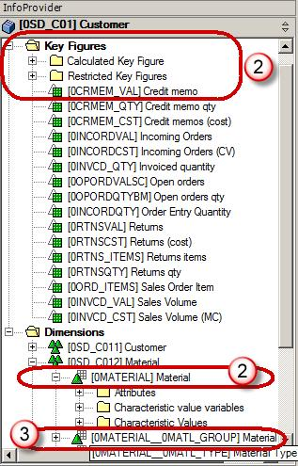](http://cdn.guru99.com/images/sap/SAP_BI/sap_bi_21_7.jpg)

**OTHER Query Elements:**

1. **Dimensions :**Similar characteristics are grouped together in a dimension. e.g. Time dimension consistsof Year, Month, Week, etc.
2. **Attributes :** Attributes define the additional properties of a characteristic. E.g. Material may have size,length or width. It is not possible to add a display attribute to a query unless the related characteristics are also added to the query. However, it is possible to set the property of characteristic as “No Display”.

[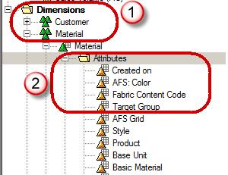](http://cdn.guru99.com/images/sap/SAP_BI/sap_bi_21_8.jpg)

**Query Properties:**

1. Select the Tab “Variable Sequence”. The tab “Variable Sequence” is used to control the order in which selection screen variables are displayed to users.
2. List the variables used in the Query. There can be multiple variables present here. These variables can be sequenced as per our need.

[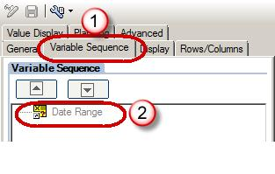](http://cdn.guru99.com/images/sap/SAP_BI/sap_bi_21_9.jpg)

1. Select the “Display” tab.
2. The Check box “Hide Repeated Key Values” controls whether the characteristic will repeat in each row or not.
3. The option “Display Scaling Factors for Key Figures” controls whether the scaling factor is reported at the top of corresponding column.

[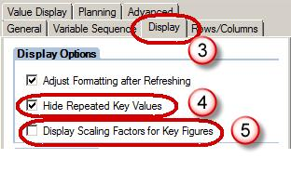](http://cdn.guru99.com/images/sap/SAP_BI/sap_bi_21_10.jpg)

1. Select the “**Advanced**” tab. The tab “Advanced” is most important from BO perspective . It controls whether the query is visible to BO or not. The option must be checked to allow query access to BO.
2. The Check box “Allow External Access to this Query” should be checked if this Query is to be used from BO

.[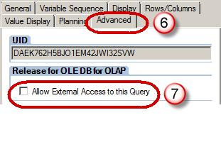](http://cdn.guru99.com/images/sap/SAP_BI/sap_bi_21_11.jpg)

1. Select the “Rows/Columns” tab.
2. The options under “Result position” section decide the Location of sub-total (a.k.a. results in BW world) as below / above or right / left of the Characteristics.
3. The options under “Suppress Zeros” section decide the application of Zero-Suppression on the query.

[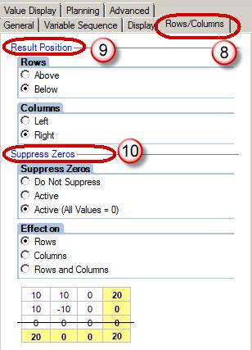](http://cdn.guru99.com/images/sap/SAP_BI/sap_bi_21_12.jpg)

**Filters:**

Filters are used to restrict the data retrieved by a query. Filters can be dynamic or static in nature. Values entered as static filters cannot be overwritten by users at runtime while dynamic filters or variables can be overwritten by user / system during query execution.

Steps to apply filters in the Query

1. Select the “Filter” tab.
2. Filters can be applied in the “Characteristic Restrictions” section.
3. Filters can be applied in the “Default values” section.

[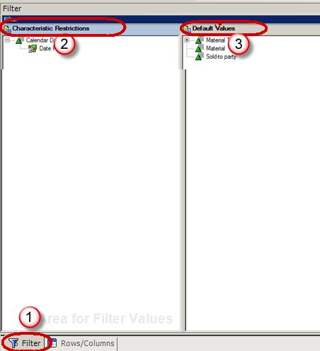](http://cdn.guru99.com/images/sap/SAP_BI/sap_bi_21_13.jpg)

Characteristic Restrictions are applied before data fetch operation, while the default values will result in entire data being fetched by query. The restriction is applied only in report front end. If “Clear all filters” option is applied in WAD / Analyzer, the filters in Default Values will be erased from front end, but the filters applied via Characteristic Restriction will still remain in force. It is recommended to have at least one or two characteristic restrictions while using a BW query for BO Universe.

**Variables:**

Variables are query parameters that we define in the Query Designer and are filled with values only when you execute the query. Variables are reusable objects. The variables defined in the Query Designer are available in all InfoProviders. They do not depend on the InfoProvider, but rather on the InfoObject for which they were created.

Types of Variables

* Characteristic values
* Hierarchies
* Hierarchy Nodes
* Texts
* Formula elements

Steps to create a variable:

**Step 1)**

1. To create a variable, browse to the folder called “Characteristic Value Variables” under the corresponding characteristic.
2. Right click on the folder and select the option “New Variable”.

[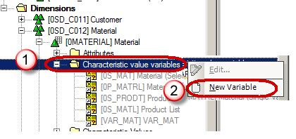](http://cdn.guru99.com/images/sap/SAP_BI/sap_bi_21_14.jpg)

**Step 2)**

1. In the subsequent window, enter the Description.
2. Enter the Technical name.
3. Variable Processing Types
4. Under reference characteristic, the variable can be assigned to either the specific InfoObject or all Info-Objects based on same reference characteristic.

[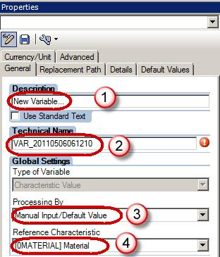](http://cdn.guru99.com/images/sap/SAP_BI/sap_bi_21_15.jpg)

1. Under the “Details” tab, we can specify whether the variable accept:
2. Single Value/ Multiple Values/ Range
3. Selection Option (allows any of the above at runtime, is not supported in BW-BO)

[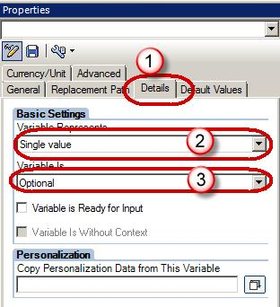](http://cdn.guru99.com/images/sap/SAP_BI/sap_bi_21_16.jpg)

**Step 3)**

1. Click the “Default values” tab.
2. We can specify the default filter applied to the report. This value can be over-written by user at run-time.

[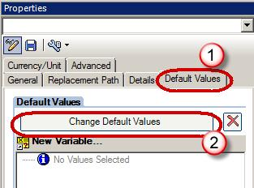](http://cdn.guru99.com/images/sap/SAP_BI/sap_bi_21_17.jpg)

**Conditions & Exceptions:**

Conditions act as filters on key figures. e.g. Top 10 customers, products with bottom 10% margin, etc.

Exceptions are similar to “conditional highlighting” in MS excel. They are used to highlight rows / columns / cells where the KPI value is above or below a certain threshold. As these are not imported to a BO Universe, we will not discuss them in details in current tutorial.

**Learn About Key & Characteristics Settings CFK, RFK & Formulas**

**Details**

Last Updated: Sunday, 04 September 2016 16:00

In this tutorial you will learn about

Characteristics Settings – Display Name

Characteristics Settings – Display Properties

Keyfigure Settings – Display Name

Keyfigure Settings – Display Properties

Keyfigures – Calculated Key Figure

Keyfigures – Restricted Key Figure

**Characteristics Settings – Display Name:**

By default, when a characteristic is added to the query, it displays the description specified in SAP BW. It is possible to replace this with customized text as follows.

1. Click on Properties
2. Select the General tab
3. Enter Description

**[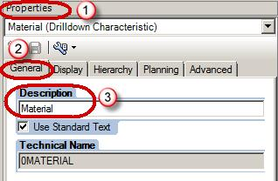](http://cdn.guru99.com/images/sap/SAP_BI/sap_bi_22_1.jpg)**

**Characteristics Settings – Display Properties:**

1. Select the Display tab of the properties window of the selected characteristic.
2. The “Display as” option is used to display either only the Key or only Text or both Key & Text.
3. If a characteristic has 2 or more of Short / Medium / Long Text populated, “Text View” is used to display corresponding text.
4. It is possible to sort data ascending / descending either by the characteristic or any of its attributes.
5. The “Result Rows” option is used to show or hide sub-total for underlying characteristic.

[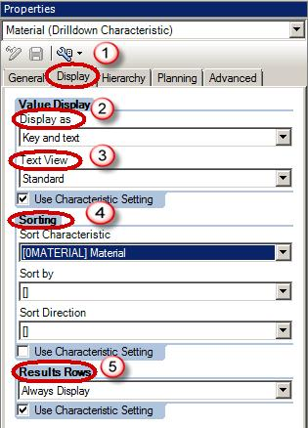](http://cdn.guru99.com/images/sap/SAP_BI/sap_bi_22_2.jpg)

**Characteristics Settings – Display Records:**

The display option is used to define what data is viewed by user during data selection (in filters) and after report execution.

1. Select the Advanced tab of the properties window of the selected characteristic.
2. Access Type for Result Values. Choose one of these values.

* “Posted values” is used to show only records that have got some transactions associated with them
* “Master Data” displays all master data records irrespective of whether a transaction exists for them or not. It is ineffective if used with zero suppression.

1. Filter Value Selection. Choose one of these values.

* Only Posted Values for Navigation: The system displays only posted values from the current navigational state.
* Only Values in InfoProvider: The system displays only values contained in the InfoProvider.
* Values in Master Data Table: It is faster, but may result in zero records matching selection criteria.

[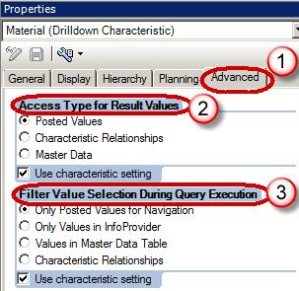](http://cdn.guru99.com/images/sap/SAP_BI/sap_bi_22_3.jpg)

**KeyFigure Settings – Display Name:**

By default, when a Key Figure is added to the query, it displays the description specified in SAP BW. It is possible to replace this with customized text as follows.

1. Click on Properties
2. Select the General tab
3. Enter Description

**[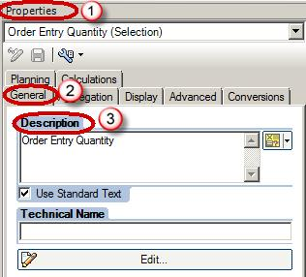](http://cdn.guru99.com/images/sap/SAP_BI/sap_bi_22_4.jpg)**

**KeyFigure Settings – Display Properties:**

1. Select the Display tab of the properties window of the selected Key Figure.
2. Hide:

* The options “Always Show” and “Always Hide” are self explanatory.
* Hide (Can be Shown) option is used to keep a key figure hidden in default output of the report. However, the user can later display this field by using filters.

1. Number of Decimals places can be used to restrict the decimal places displayed in report.
2. Scaling factor is used to show data in thousands / hundreds / etc.
3. The sign of key figures can be reversed if required. e.g. Sales Quantity is negative movement from Inventory perspective, but positive from sales perspective and we can reverse sign based on user.

[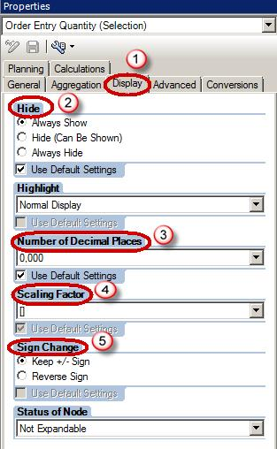](http://cdn.guru99.com/images/sap/SAP_BI/sap_bi_22_5.jpg)

**KeyFigure Settings – Currency Or Unit Conversion:**

BW does not allow cumulating amount in different units e.g. one rupee to one dollar or one kilogram to one yard. When data exists in multiple currencies / unit, all records must be converted to single currency / unit using Currency Translation / Unit Conversion. The translation can be dynamic (by using selection screen variable) or static (with target currency / unit hardcoded in adjacent screens). Advantage of doing this in SAP BW is that it directly imports the conversion factors available in SAP ERP to SAP BW.

1. Select the Conversions tab.
2. For currency translation, this option can be used.
3. For unit conversion, this option can be used.

[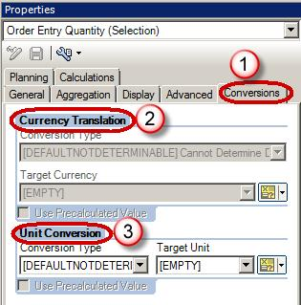](http://cdn.guru99.com/images/sap/SAP_BI/sap_bi_22_6.jpg)

**KeyFigure Settings – Aggregation:**

Query Designer gives the flexibility of calculating aggregates as average, summation, minimum,

etc. Similar calculations can also be performed on row-level data.

1. Select the Calculations tab.
2. Select from the Different options available under the drop-down of “Calculate Results As”.

[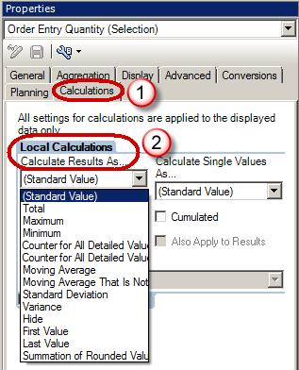](http://cdn.guru99.com/images/sap/SAP_BI/sap_bi_22_7.jpg)

**KeyFigures – Local Formula:**

BW, allows use of formulae, on data coming from InfoProvider, to provide calculated values to user.

e.g. Subtracting Cost from Revenue to calculate Profit

**Steps to create Formula:**

**Step 1)**

1. Right click on the structure “Key Figure”
2. Click on “New Formula”

[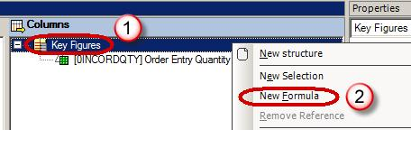](http://cdn.guru99.com/images/sap/SAP_BI/sap_bi_22_8.jpg)

**Step 2)**

Click on the edit button of properties box to create / edit a local formula

[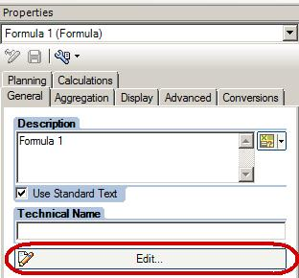](http://cdn.guru99.com/images/sap/SAP_BI/sap_bi_22_9.jpg)

**Step 3)**

Some of the common operators used in BW include:

* Addition, Subtraction, Multiplication and Division
* NODIM is used to display key figures without their corresponding unit
* NOERR is used to display zero instead of error message (e.g. zero instead of mentioning that division by zero error)
* %GT is used to show the value of key figure as a percentage of total value

1. In the “Detail View” box, enter the formula
2. Use the operators from the “Operators” box.

[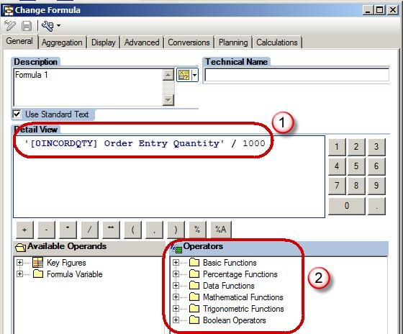](http://cdn.guru99.com/images/sap/SAP_BI/sap_bi_22_10.jpg)

**KeyFigures – Calculated Key Figure:**

If same calculation is required for multiple reports, it can be mapped to the InfoProvider instead of creating it individually in each query. Such key figure is called “Calculated Key Figure” or CKF.

Once defined, it can be dragged into a query like any other key figure. The biggest advantage of this approach is that it facilitates global definitions of common calculated KPIs.

**Steps to create a Calculated Key Figure:**

1. Navigate to the Infoprovider section
2. Right Click on Keyfigures folder.
3. Choose the option “New Calculated Key Figure”.

[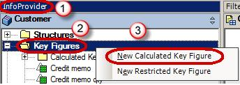](http://cdn.guru99.com/images/sap/SAP_BI/sap_bi_22_11.jpg)

**KeyFigures – Restricted Key Figure:**

Restricted Key Figures (RKF) can be used to selectively apply filters only to a specific KPI in the report, but not to the entire report e.g. split sales into columns like YTD (Year To Date)  Sales, PYTD (Previous Year To Date) Sales, etc.

**Step 1)**

1. Navigate to the Infoprovider section
2. Right Click on Keyfigures folder.
3. Choose the option “New Restricted Key Figure”.

[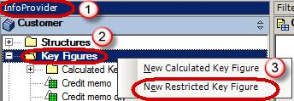](http://cdn.guru99.com/images/sap/SAP_BI/sap_bi_22_12.jpg)

**Step 2)**

Click on the edit button of properties box to create / edit a RKF

[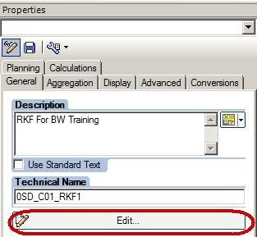](http://cdn.guru99.com/images/sap/SAP_BI/sap_bi_22_13.jpg)

**Step 3)**

In the subsequent screen, at least one key figure and one characteristic must be entered to make a meaningful RKF.

1. Keyfigure which is to be restricted.
2. The characteristic may be restricted by a selection screen variable to make it “Dynamic” RKF.
3. It may also be restricted by a constant e.g. year = 2008. In the below screen shot, version is restricted with constant value “1”.

[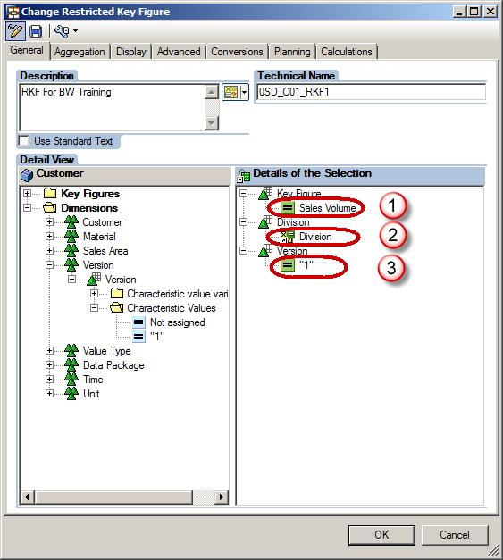](http://cdn.guru99.com/images/sap/SAP_BI/sap_bi_22_14.jpg)

Like CKF, RKFs are also global to the InfoProvider and can be reused in multiple queries using the same InfoProvider.